

**LINUX SERVER MISCONFIGURATIONS & HARDENING METHODS**

Done by:

**Nabil Aldaasin, Zeyad Abu Laban,**

**Omar Albalouli, Mohammad Alshalabi**

Supervised by:

**Dr. Belal Ayyoub**

**Presented to the Department of Computer Engineering**

**At Al-Balqa'a Applied University**

**January, 2022**

**ABSTRACT**

A vulnerable linux server with common vulnerabilities and misconfigurations to demonstrate how an attacker can compromise the server by abusing them and teaching aspiring sysadmins and developers how to avoid making such mistakes and help them build a server with low security risks, to ensure the integrity and confidentiality of users and customers information.

**LINUX SERVER MISCONFIGURATIONS & HARDENING METHODS**

By:

**Nabil Aldaasin, Zeyad Abu Laban**

**Omar Albalouli, Mohammad Alshalabi**

**Approved by:**

**Supervisor: Dr. Belal Ayyoub**

**Table of Contents**

CHAPTER 1: INTRODUCTION 8

1.1 Overview 8

1.2 Problem Statement 9

1.2.1 User home permissions 9

1.2.2 setgid and setuid binaries 9

1.2.3 World readable and writable files/folders 10

1.2.4 Weak services or configurations 10

1.2.5 Default mount options or insecure export options 10

1.3 Aims and Objectives 11

1.4 Documentation Layout 11

CHAPTER 2: RELATED WORK 12

2.1 METASPLOITABLE 2 12

1. vsFTPd 2.3.4 backdoor 12

2. UnreaIRCD 3.2.8.1 12

3. Web services to practice web vulnerabilities exploitation 12

2.2 CAP MACHINE 13

2.3 H4CKED MACHINE 20

CHAPTER 3: SETTING UP THE ENVIRONMENT 25

3.1 Vagrant 25

3.2 Configuration 27

3.2.1 Server Folder 27

3.2.2 Folder webserver 31

CHAPTER 4: IMPLEMENTATION AND RESULTS 37

4.1 Enumeration and information collecting 37

4.1.1 Nmap scan 37

4.1.2 WPSCAN 39

4.2 Initial Compromise 41

4.2.1 Exploiting LFI to read admin credentials 42

4.3 Establishing Foothold 44

4.3.1 Logging in as the user mohammad 45

4.3.2 Getting a reverse shell 47

4.4 Escalating Privileges 53

4.4.1 From www-data to baker 53

4.4.2 From baker to nabil 57

4.4.3 From nabil to root 63

CHAPTER 5: CONCLUSIONS AND FUTURE WORK 66

5.1 Conclusions 66

5.2 Future Work 66

References 67

**Table of Figures**

Figure ‎1.1 Linux servers in a data center 9

Figure ‎2.1 Metasploitable 2 13

Figure ‎2.2 Cap Machine 14

Figure ‎2.3 The web UI and the /data/00 page 15

Figure ‎2.4 The FTP data packets inside the PCAP file 15

Figure ‎2.5 The password in clear text form in the FTP packets 16

Figure ‎2.6 Following the full TCP stream of the FTP connection 16

Figure ‎2.7 Connecting to the machine through FTP as the user Nathan 17

Figure ‎2.8 Connecting to the machine through SSH as the user Nathan 18

Figure ‎2.9 Enumerating for capabilities and finding cap_setuid for python3 18

Figure ‎2.10 Exploiting cap_setuid in python3 to gain root privileges 19

Figure ‎2.11 H4cked Machine 20

Figure ‎2.12 Port Scanning 20

Figure ‎2.13 Using Hydra for Brute Forcing 21

Figure ‎2.14 Logging into the FTP server 21

Figure ‎2.15 Uploading shell.php 22

Figure ‎2.16 Visiting the website 22

Figure ‎2.17 Getting a reverse shell 23

Figure ‎2.18 Getting root access 23

Figure ‎3.1 The content of a Vagrant file 25

Figure ‎3.2 Network and Folders settings in the Vagrant file 26

Figure ‎3.3 Provisioning settings in the Vagrant file 26

Figure ‎3.5 Server Folder 27

Figure ‎3.6 backup.sh 28

Figure ‎3.7 config.sh 28

Figure ‎3.8 debug.service 29

Figure ‎3.9 restart_services 30

Figure ‎3.10 sudoers file 31

Figure ‎3.11 Apache configration file 33

Figure ‎3.12 Threats.int home section 34

Figure ‎3.13 Threats.int about section 35

Figure ‎3.14 Threats.int meet our team section 35

Figure ‎3.15 Threats.int our sevices section 36

Figure ‎3.16 Threats.int contact section 36

Figure ‎4.1 Nmap scan results 38

Figure ‎4.2 WPScan tool results (1) 40

Figure ‎4.3 WPScan tool results (2) 40

Figure ‎4.4 WP with spritz exploit 41

Figure ‎4.5 The results of reading /etc/passwd file using curl command 43

Figure ‎4.6 The results of reading /etc/passwd file using the browser 43

Figure ‎4.7 wp-config.php contents 44

Figure ‎4.8 Threats.int admin panel 45

Figure ‎4.9 Threats.int admin dashboard 46

Figure ‎4.10 Threats.int users 47

Figure ‎4.11 Wordpress malicious plugin 48

Figure ‎4.12 Netcat listening on port 9001 49

Figure ‎4.13 Upload the malicious plugin 51

Figure ‎4.14 Activate the malicious plugin 52

Figure ‎4.15 receive reverse shell 53

Figure ‎4.16 The cronjob file contents 54

Figure ‎4.17 The backup script 54

Figure ‎4.18 The RSA key for the attacker machine 55

Figure ‎4.19 malicious-script.sh file contents 56

Figure ‎4.20 Trying to connect to baker using ssh 57

Figure ‎4.21 sudo -l command results 58

Figure ‎4.22 restart_services script content 58

Figure ‎4.23 debug.service file content 60

Figure ‎4.24 Run the docker command 63

Figure ‎4.25 Getting root access 65

Figure ‎4.26 Congratulations on Successfully Hacking this Server 65

# CHAPTER 1: INTRODUCTION

## Overview

System hardening is the process of securing a server or computer system by minimizing its attack surface, or surface of vulnerability, and potential attack vectors. It’s a form of cyberattack protection that involves closing system loopholes that cyber attackers frequently use to exploit the system and gain access to users’ sensitive data. One official definition of system hardening is that it’s “a process intended to eliminate a means of attack by patching vulnerabilities and turning off non-essential services.”.

Part of the system hardening elimination process involves deleting or disabling needless system applications, permissions, ports, user accounts, and other features so that attackers have fewer opportunities to gain access to a mission-critical or critical-infrastructure computer system's sensitive information. But at its core, system hardening is a method for protecting a system against attacks perpetrated by cybercriminals. It involves securing a computer system’s software mainly but also its firmware and other system elements to reduce vulnerabilities and a potential compromise of the entire system.



Figure ‎1.1 Linux servers in a data center

## Problem Statement

This project concentrates on showcasing how an attacker can leverage weak server implementations to compromise and exfiltrate PII (Personally Identifiable Information) data, some of the weak permissions are:

### User home permissions

On most Linux distributions the default permissions for home folders is 755 which means that any user who has access to the server can see what is in other user’s home folders. Some users such as administrators or developers may have scripts or backups of files in their home folders which contain sensitive information such as user passwords and keys to services to the same or other servers on the network.

### **setgid and setuid binaries**

The set uid bit on a file is dangerous because it allows that file to run as a potentially privileged user such as root. If a file is owned by root and had the set uid bit set the file will run with the privileges of root. This means that if an attacker can find a vulnerability or unexpected uses of that file he can then perform commands on the system as the root user which means a full compromise of the server.

### World readable and writable files/folders

World-readable and writable files and folders introduce similar issues as loose user home permissions but throughout the system. The main cause of world readable files is the default umask used for file creation of either 0022 or 0002. As a result of this configuration weakness, files that may contain sensitive information will be readable by anyone that has access to the system. Files may also be modified by anyone on the system if they are world-writable. This can lead to an attacker modifying files or scripts to hide forensic evidence or to execute commands by modifying a script used by Administrators.

### Weak services or configurations

Services are configured with the minimum configuration changes needed to get them up and running. It is not uncommon to find services Also, Weak and possibly default credentials and configurations when using less secure communication channels are also typical, increasing the risk and attack surface of the server. When using services the options and configuration should be reviewed to ensure that what is being deployed is secure or properly configured. It’s also not uncommon to find these services bound to multiple interfaces on the server instead of just listening locally or just on the specified interface.

### Default mount options or insecure export options

The defaults keyword for all mounts have the following options “rw, suid, dev, exec, auto, nouser, and async”. These options are weak since they allow for the honoring of the suid and guid bits that are set on externally mounted file systems via protocols such as NFS. When exporting NFS shares it is recommended that the no_root_squash option not be set. The root-squash option is the default behavior but it is commonly seen to be changed. If root-squashing is not done it allows users to create files on the exported NFS share as the root user. These weaknesses, if left as defaults, can allow for root access on servers where such access is not provided for users.

## Aims and Objectives

The aim of server hardening is to reduce the attack surface of the server. The attack surface is all the different points where an attacker can attempt to access or damage the server. This includes all network interfaces and installed software. By removing software that is not needed and by configuring the remaining software to maximize security the attack surface can be reduced. As a result, an attacker has fewer opportunities to compromise the server, but unfortunately there are still common misconfigurations being made and present in the wild so we decided to discuss these misconfigurations in our project.

## Documentation Layout

This project is organized as follows, in the second chapter will discuss the previous work done with other created misconfigured linux servers, and the methods used to compromise them.

The third chapter will give a guidance for the environment setup used in the misconfigured server and will give the misconfigurations used in the server. The fourth chapter will elaborate how an attacker could abuse those misconfigurations for their malicious intentions and will show the attack and results done on the misconfigured linux server and will discuss these results.

Finally, chapter five will give a conclusion of the work.

# CHAPTER 2: RELATED WORK

## METASPLOITABLE 2

Metasploitable is an intentionally vulnerable Linux virtual machine that can be used to conduct security training, test security tools, and practice common penetration testing techniques.

Download [link.](https://docs.rapid7.com/metasploit/metasploitable-2)

This server discusses the following misconfigurations and vulnerabilities:

1. vsFTPd 2.3.4 backdoor**:** This version contains a backdoor that was slipped into the source code by an unknown intruder If a username is sent that ends in the sequence **:)** [a happy face], the backdoored version will open a listening shell on port 6200 which an attacker can use to execute commands on the server. [CVE link](https://www.exploit-db.com/exploits/49757)
2. UnreaIRCD 3.2.8.1**:** This version contains a backdoor that went unnoticed for months - triggered by sending the letters "AB" followed by a system command to the server on any listening port.
3. Web services to practice web vulnerabilities exploitation**:** 
   1. Mutillidae (NOWASP Mutillidae 2.1.19)
   2. DVWA (Damn Vulnerable Web Application)
   3. phpMyAdmin
   4. tikiwiki (TWiki)
   5. tikiwiki-old
   6. dav (WebDAV)

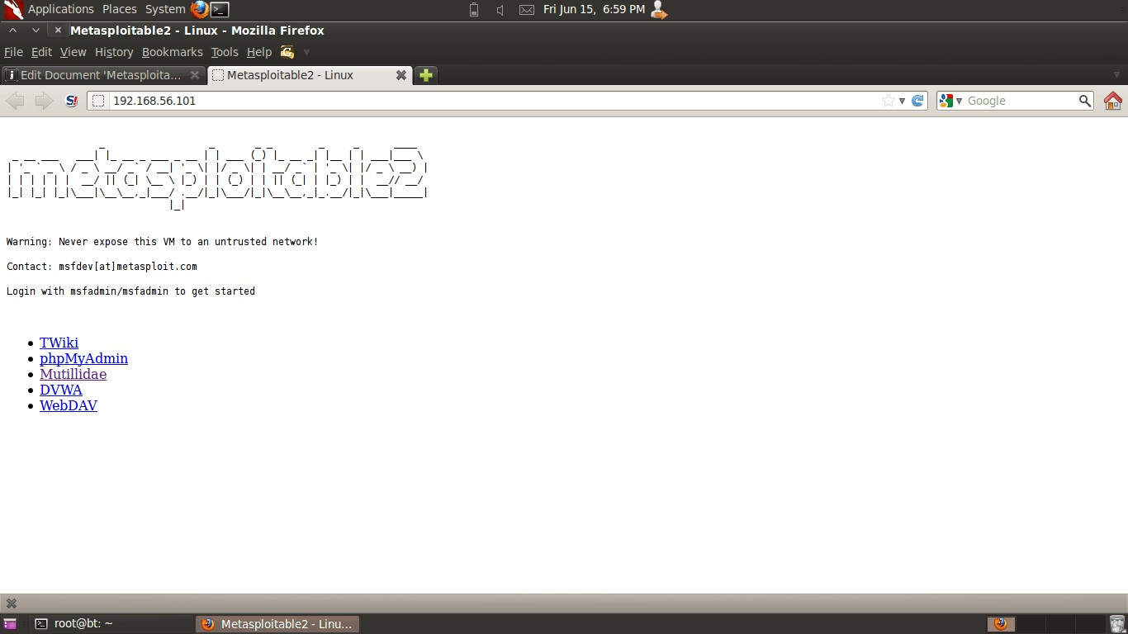

Figure ‎2.1 Metasploitable 2

It is quite hard to fairly compare between Metasploitable 2 and our machine even though their purpose is the same, to gain and expand one’s knowledge about security vulnerabilities and the risks that are caused by them and to practice and sharpen one’s penetration testing and security skills.

Metasploitable 2 is more focused on providing as many vulnerabilities as possible to practice on them all but without having approaches or scenarios that are close to what’s happening in real life and it’s more beginner friendly than our machine.

## CAP MACHINE

Cap is a virtual machine that contains several vulnerabilities which could let an attacker gain administrative privileges (root privileges) on the machine with simple yet high-impact vulnerabilities, this machine is provided from HackTheBox platform, it’s an online penetration testing training platform that is aimed for intermediate and high-skilled penetration testing students and security engineers.

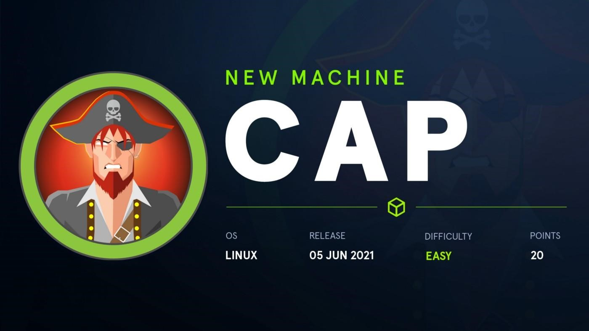

Figure ‎2.2 Cap Machine

The first vulnerability can be found while navigating the web application user interface on this machine, and this vulnerability is [IDOR (](https://portswigger.net/web-security/access-control/idor)Insecure Direct Object References), it’s a logic vulnerability that could let the attacker leak arbitrary files and sensitive information, such as PII

(Personally Identifiable Information), in this case, the attacker abuses this to read another user’s (Nathan) PCAP file which contains FTP credentials in clear text form, which can be found by enumerating the /data directory and the files that are in it, in this case the file with the name “00” was the interesting PCAP file, and by using this information within that file, the attacker can get an initial foothold on the server.

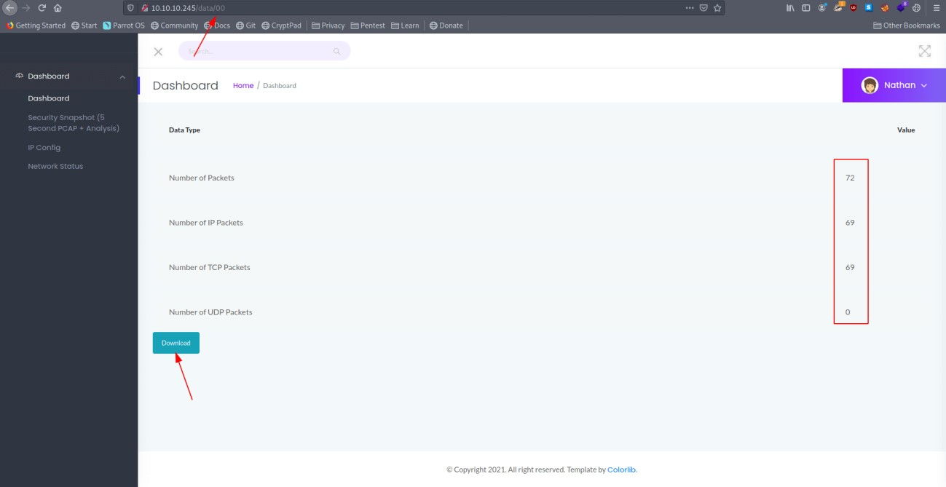

Figure ‎2.3 The web UI and the /data/00 page

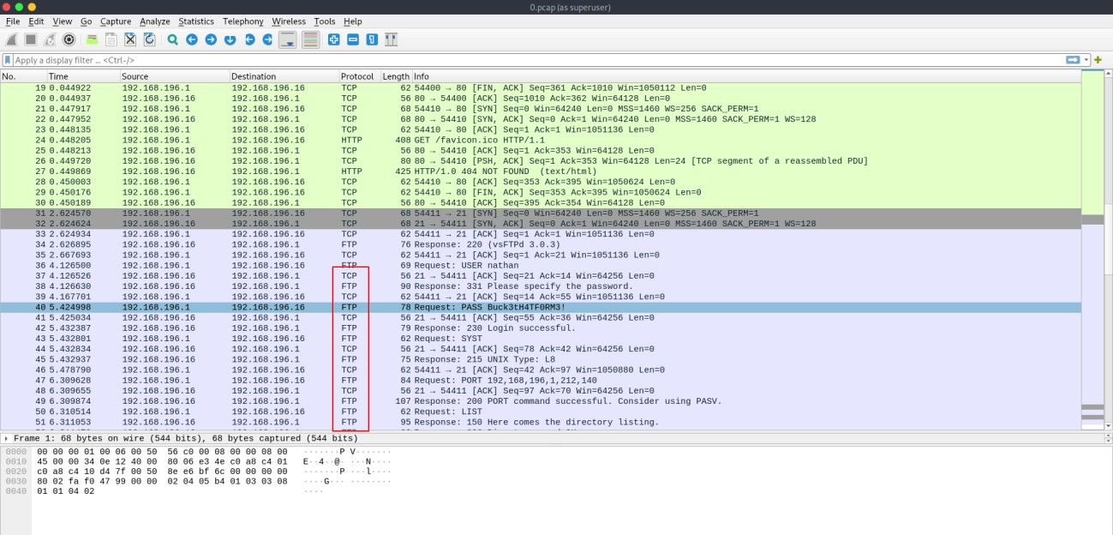

Figure ‎2.4 The FTP data packets inside the PCAP file

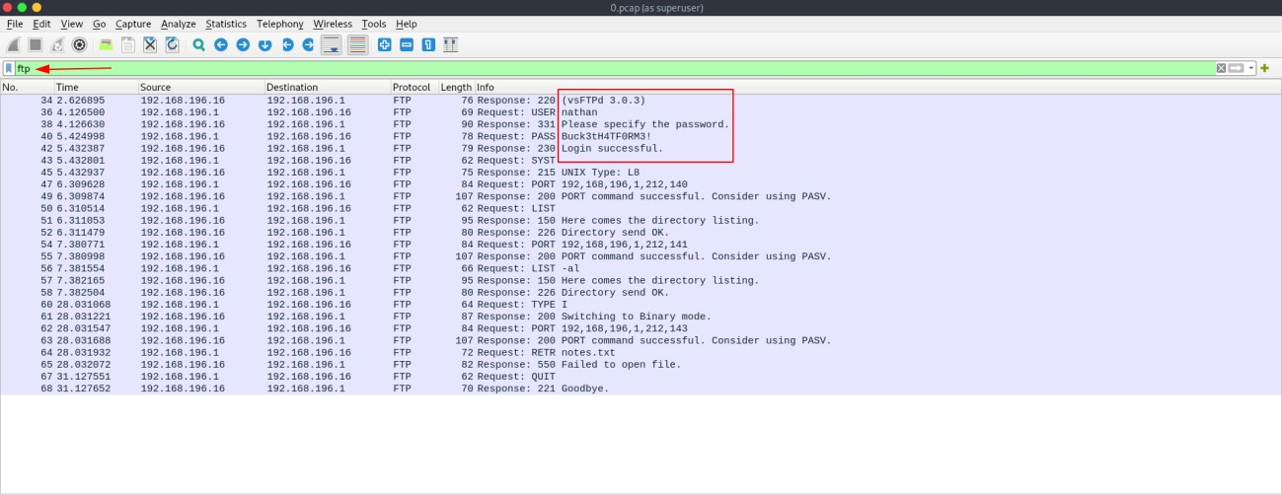

Figure ‎2.5 The password in clear text form in the FTP packets

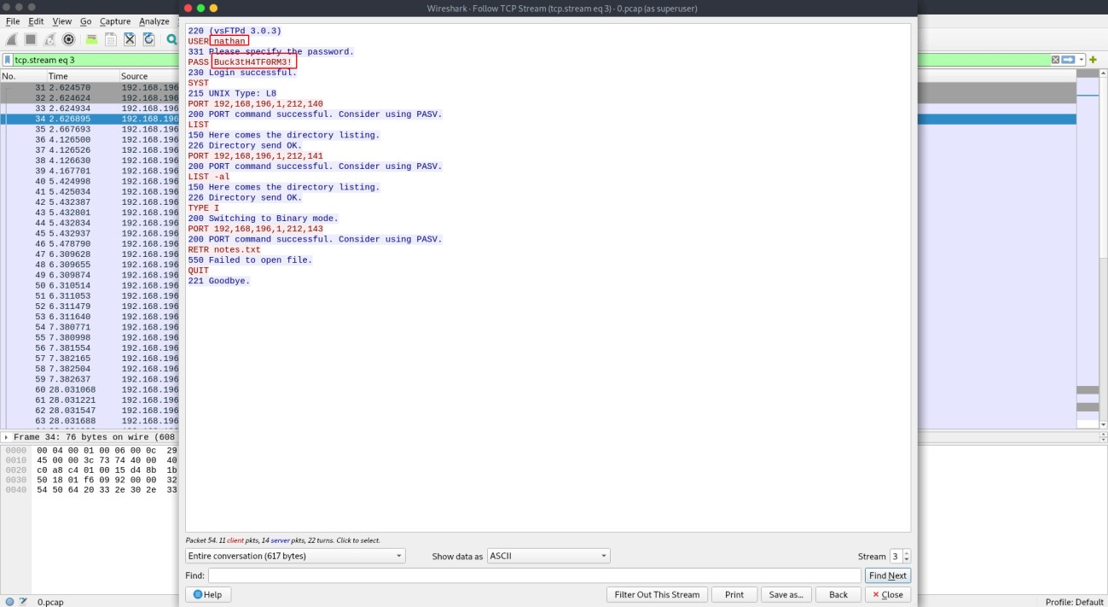

Figure ‎2.6 Following the full TCP stream of the FTP connection

The attacker can test this password by connecting to the server through FTP and try to authenticate as the user Nathan with the acquired password.

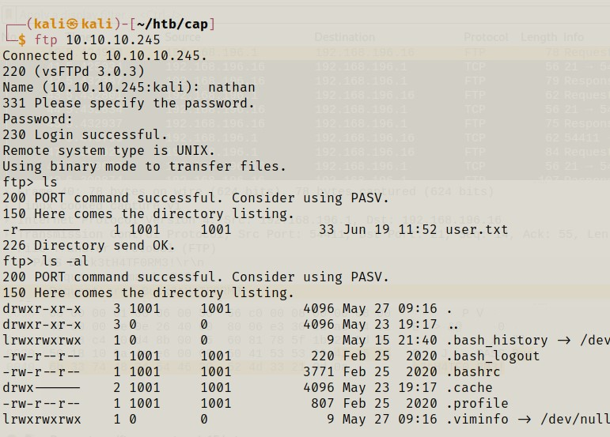

Figure ‎2.7 Connecting to the machine through FTP as the user Nathan

The attacker uses this password to login through SSH as the user Nathan, and this shows us that password reuse can lead to security risks.

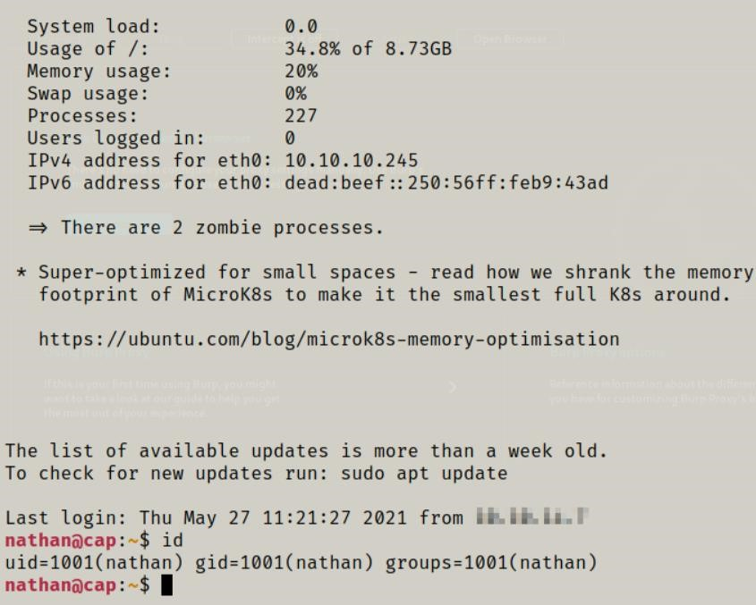

Figure ‎2.8 Connecting to the machine through SSH as the user Nathan

Now that the attacker is logged-in as the user Nathan, they start to enumerate the system for more vulnerabilities, and they find that python3 has the capability to change any UID for any user with cap_setuid.

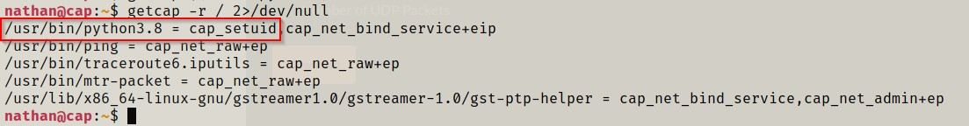

Figure ‎2.9 Enumerating for capabilities and finding cap_setuid for python3

The attacker can then exploit this to execute a python command that can let them maintain privileged access by manipulating its own process UID to 0, which is the root’s UID, thus having root privileges on the system.



Figure ‎2.10 Exploiting cap_setuid in python3 to gain root privileges

While Cap and our machine have the same purpose and a similar approach; which is gaining a foothold by exploiting a vulnerability that is exposed to the public, logging in as one of the users on the machine and finding a way to escalate their privilege to root, which means that they have full access on the machine, Cap machine have a much simpler approach than ours.

Compared to our machine, Cap is an easy machine with a scenario that is rare to happen in real life, unless there were a really lazy system administrator that would expose their server and production environment to danger in such a way.

## H4CKED MACHINE

H4kced is a machine that shows the impact of having bad password policies such as using weak passwords and reusing the same password on multiple accounts/services. Yet using weak and simple passwords is a recipe for data breaches, account takeovers, and other forms of cyberattack. This machine is provided by TryHackMe, which is a website that teaches you by doing instructions and lessons unlike HackTheBox, where you're on your own.



Figure ‎2.11 H4cked Machine

The first thing the attacker did was simple port scanning using the NMAP tool. He found three open ports 21, 22 and 80.

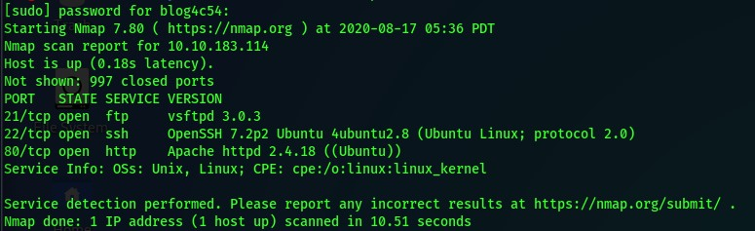

Figure ‎2.12 Port Scanning

Then the attacker tried to crack the FTP password using Hydra tool, which is a famous tool used to crack passwords by brute-forcing. He used the built-in wordlist “rockyou.txt” which contains 14,341,564 unique passwords, used in 32,603,388 accounts.

He managed to get a password for the user ”jenny”.

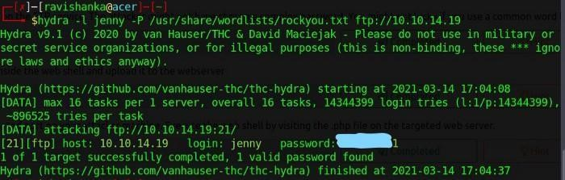

Figure ‎2.13 Using Hydra for Brute Forcing

Now he will login into the FTP server

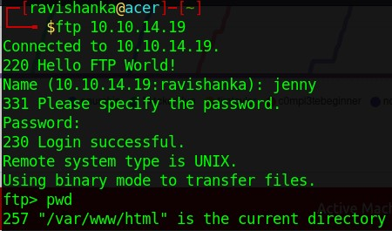

Figure ‎2.14 Logging into the FTP server

Now after logging in to the FTP server, the attacker needs to get a reverse shell to get access to the server. So he will upload a malicious file (shell.php) which is a script that will open an outbound TCP connection from the webserver to the attacker IP address.

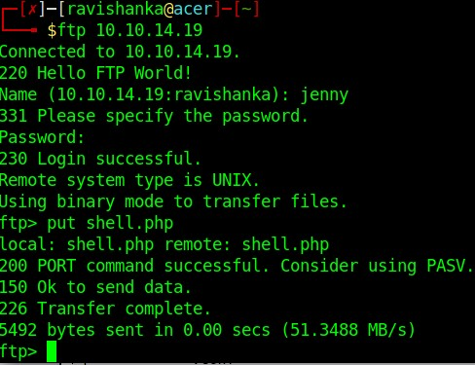

Figure ‎2.15 Uploading shell.php

Now he had to open the web server homepage to execute the script.

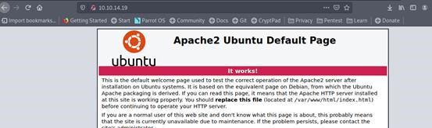

Figure ‎2.16 Visiting the website

Now he got a reverse shell.

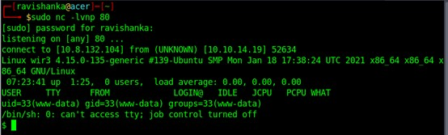

Figure ‎2.17 Getting a reverse shell

Now he has access to the server, but it’s limited because it’s a webserver user (www-data). So, he tried to switch to the root user, and luckily the root password was the same as the FTP password.

This shows the high impact of using the same password on multiple accounts/services.

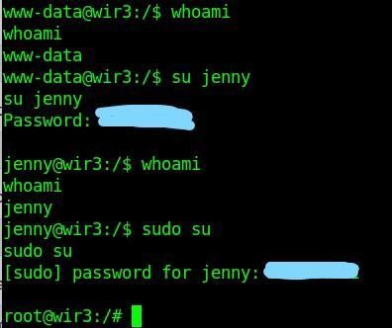

Figure ‎2.18 Getting root access

While H4cked and our machine have a similar approach, which is gaining a foothold by exploiting a vulnerability that is exposed to the public, logging in as one of the users on the machine and finding a way to escalate their privilege to root, which means that they have full access on the machine, this machine is mainly targeted for beginners who just started their cybersecurity learning path by teaching them how to penetrate their way in by asking them questions that will guide them to compromise the machine while they’re learning.

Compared to our machine, H4cked is a beginners-targeted machine with a situation that you mostly won’t find in real life since the whole environment had been set up for learning purposes on basic vulnerabilities to get students started, and there aren’t as many common vulnerabilities as there are on the internet in this machine.

# CHAPTER 3: SETTING UP THE ENVIRONMENT

This chapter will show how the vulnerable and misconfigured environment is made; all of the files are in the project’s Github repository.

## Vagrant

We used Vagrant, which is an open-source software product for building and maintaining portable virtual software development environments (Journal, n.d.).

to create our environment in a virtual machine with apps and services automatically installed and configured based on our needs for this thesis to demonstrate the risks of running vulnerable or misconfigured apps and services.

By simply running “vagrant up” it will start creating the virtual machine based on the provided vagrant file in the current working directory by default.

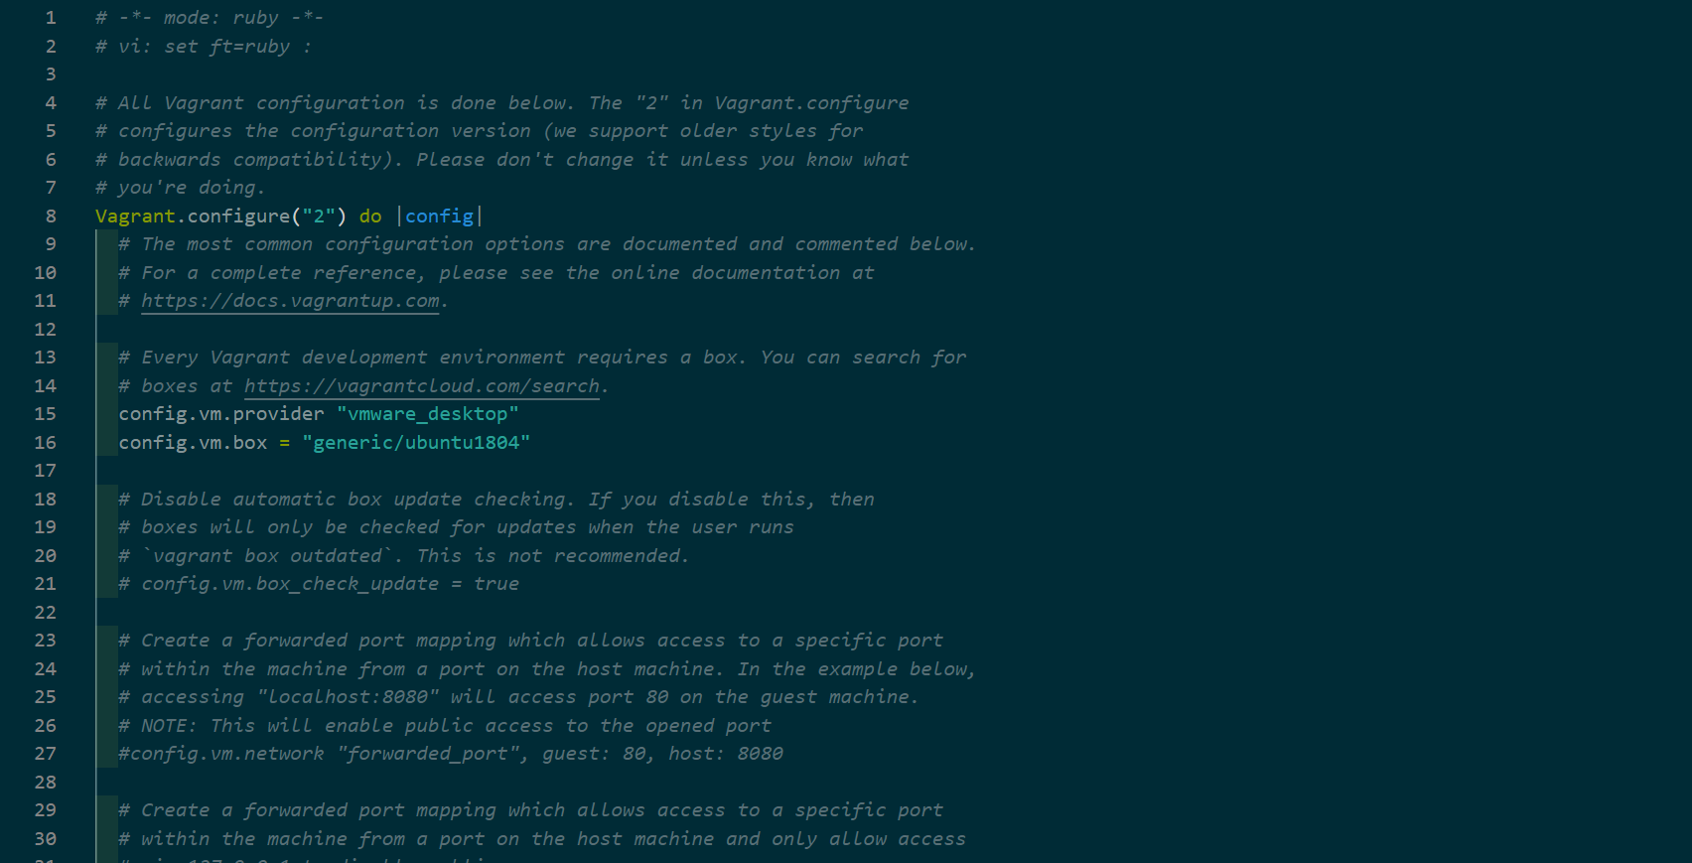

Figure ‎3.1 The content of a Vagrant file

It will start by downloading the operating system if there’s no available image does already exist for Vagrant to use, it will then boot up and install the operating system and configure it.

Here we configure Vagrant to assign the IP 192.168.77.105 for the virtual machine to use, and to map and sync our local folders “configuration” and “Setup-Project” with the virtual machine

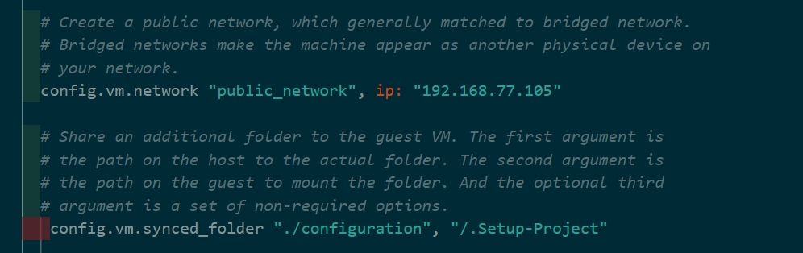

Figure ‎3.2 Network and Folders settings in the Vagrant file

And finally, we configure how will Vagrant provision the virtual machine, here we are configuring it by running a bash script in which it will setup and configure all of the vulnerable and misconfigured apps and services for this thesis.

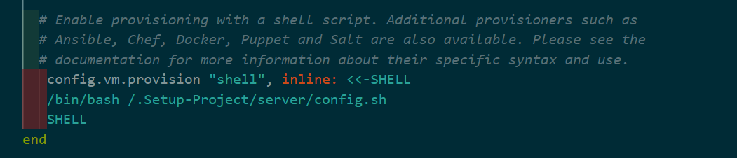

Figure ‎3.3 Provisioning settings in the Vagrant file

## Configuration

In the **configuration** folder there are two other folders that are needed to create the vulnerable server, they contain the

### Server Folder

The server folder contains those files that are needed for the applications and users to work as intended, note that all of them are misconfigured and using them will compromise the server.

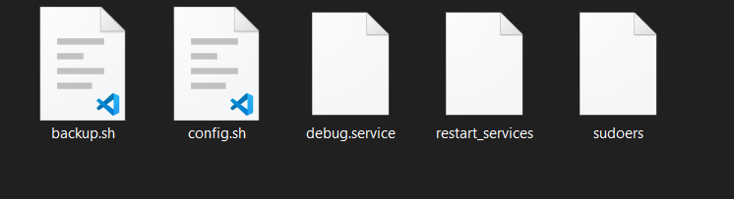

Figure ‎3.5 Server Folder

* **backup.sh:**  
  This file is being run by a cron job from by user **baker** to take a backup of all the files inside the source directory and compress it to a file named **webapp.tgz** located in the destination directory.

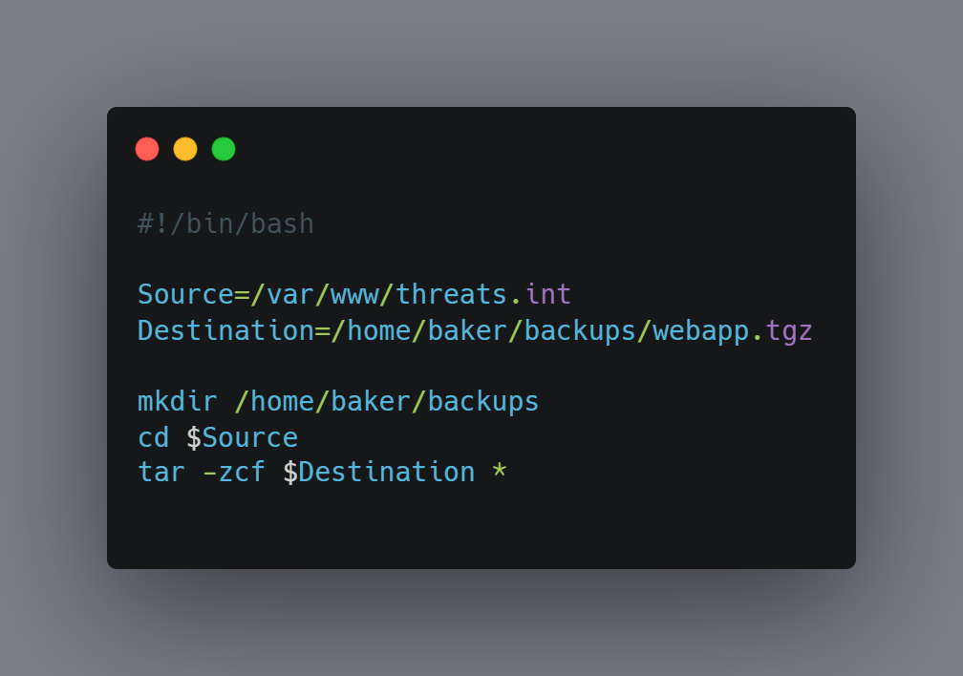

Figure ‎3.6 backup.sh

* **configs.sh:**  
  This file will run after booting up the machine (by **Vagrant**) from the **root** user and it’ll setup requirements, configurations, and network settings for the applications to run on the server.

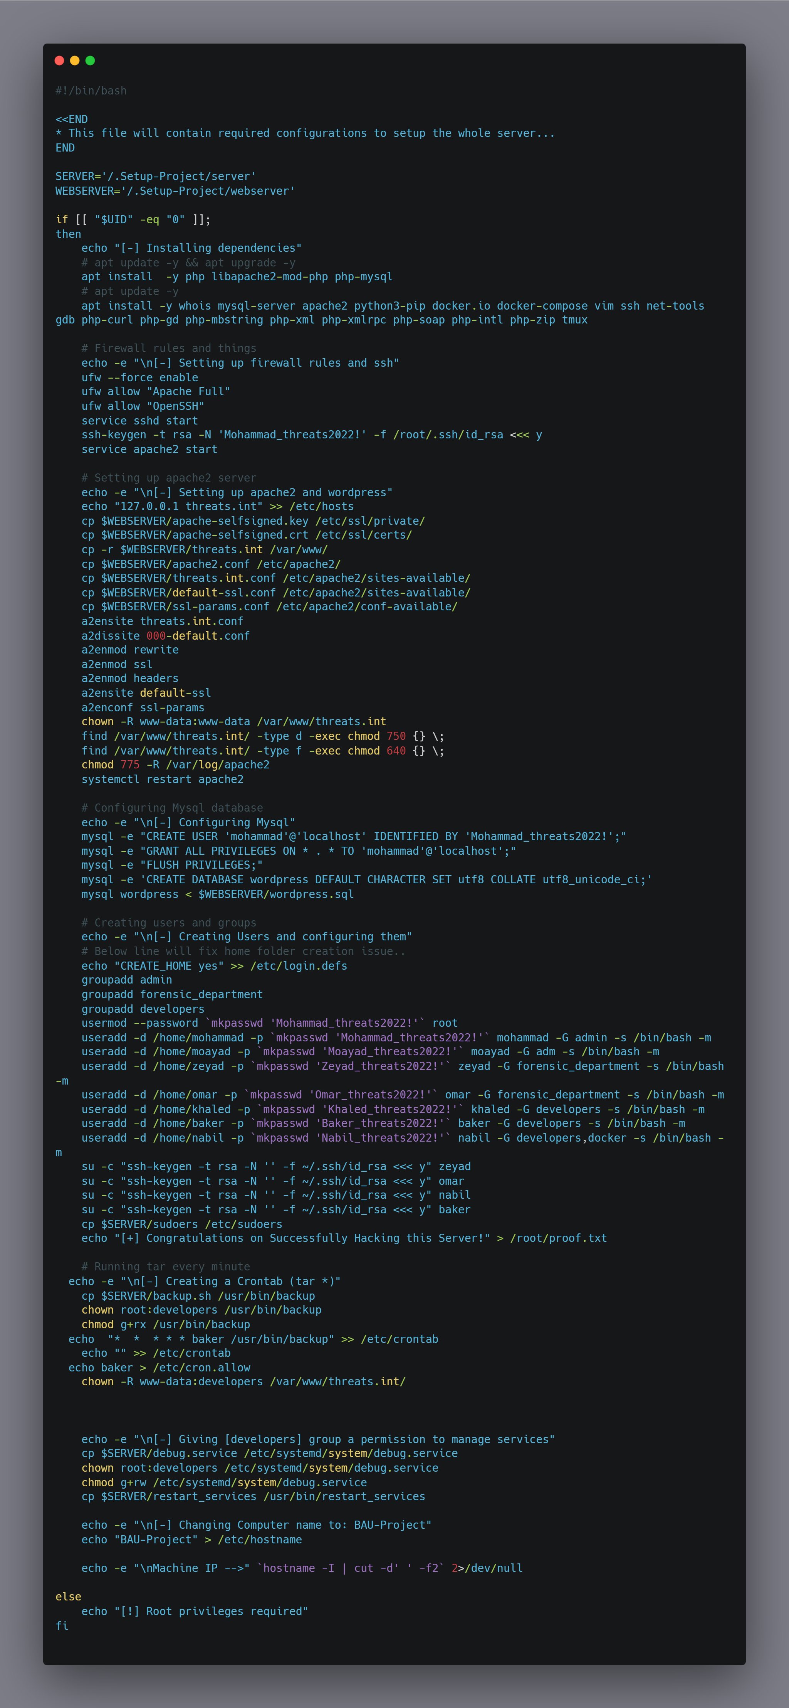

Figure ‎3.7 config.sh

* **debug.service:**This is a service file that is owned by the **developers** group and can be used by the user **baker**.

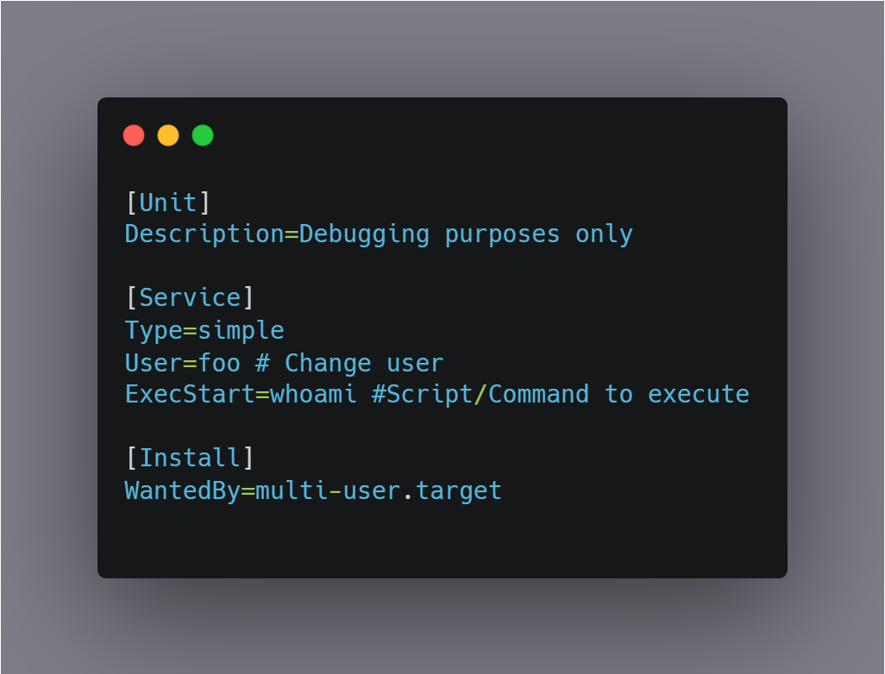

Figure ‎3.8 debug.service

* **restart_services:**  
  This file is the user-privilege based restart service script and its purpose is to prevent users from restarting services that are managed by the root user and permit restarting if otherwise.

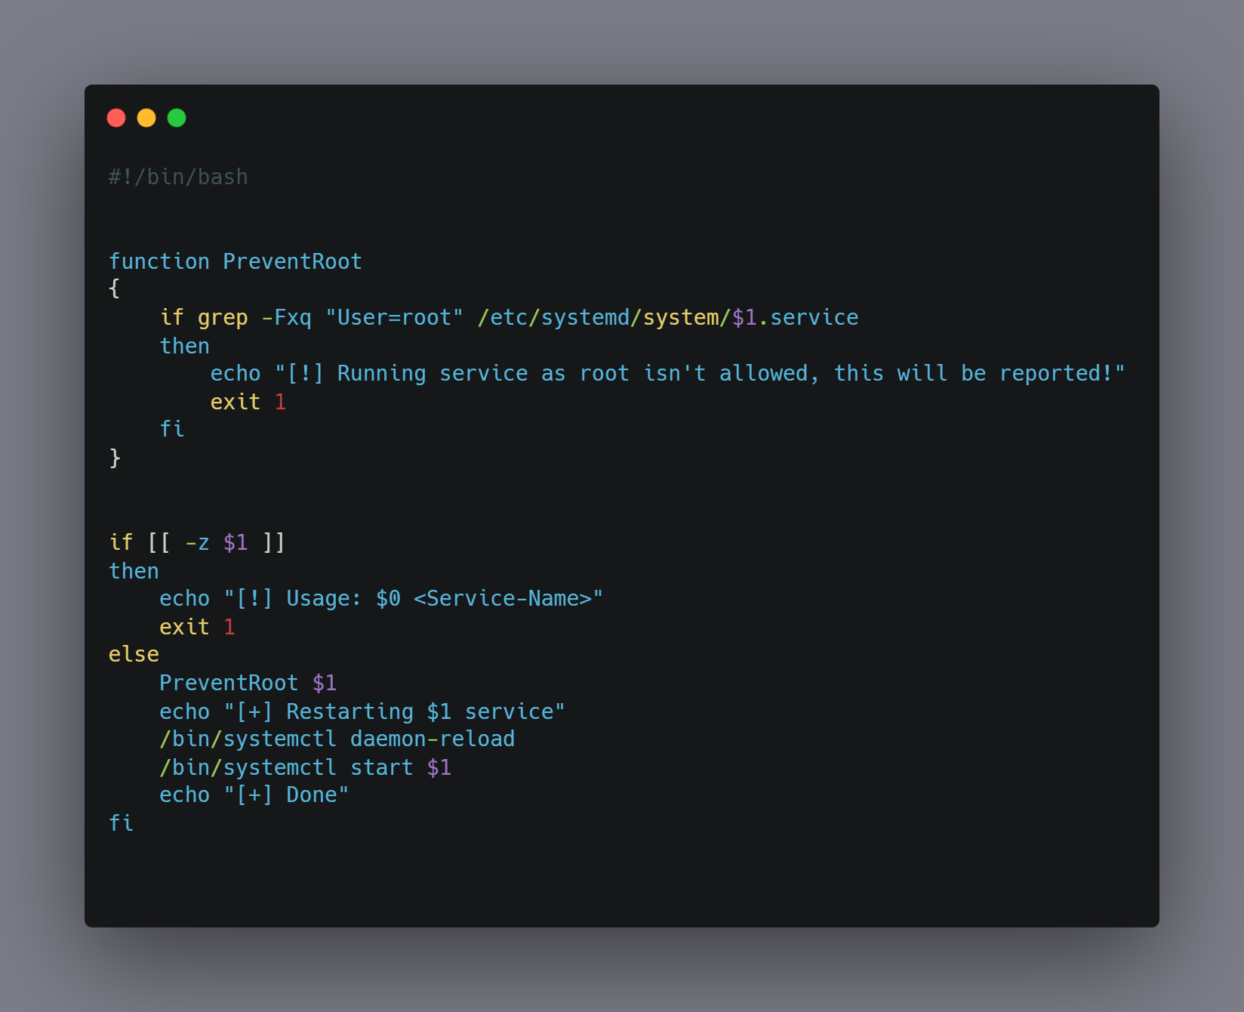

Figure ‎3.9 restart_services

* **sudoers:**  
  This file is a pre-configured **sudoers** file, note that the user **nabil** can run **docker** with **root** privileges as well as everyone in the **developers** group can execute the file **restart_services** with root privileges.

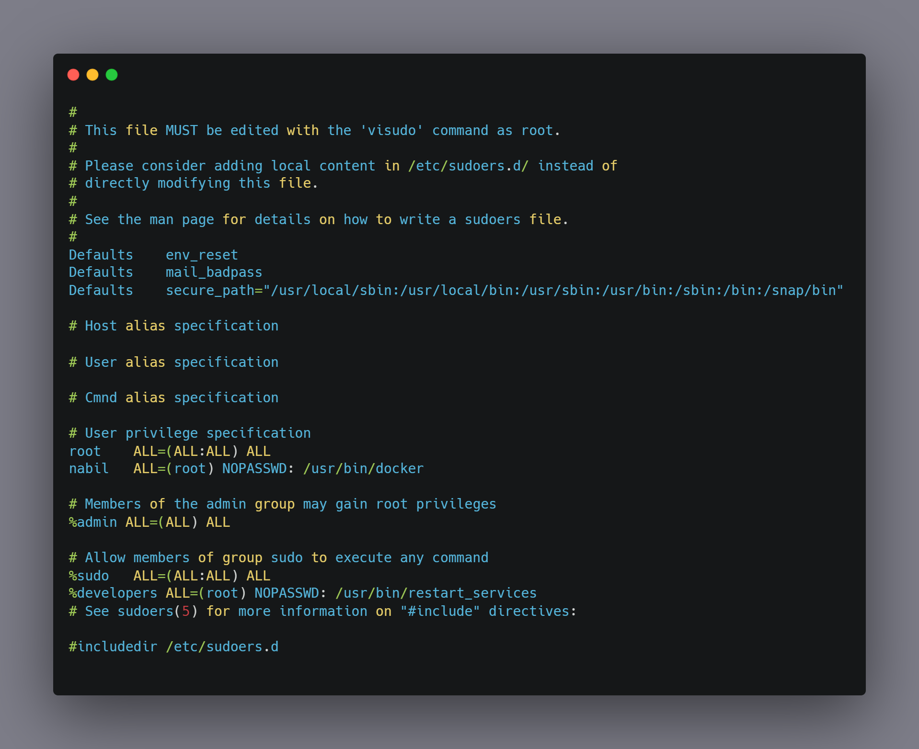

Figure ‎3.10 sudoers file

### 3.2.2 Folder webserver

The web server contains the WordPress application, which has the user interface for a security company, and the vulnerable plugin, which is affected by an LFI vulnerability which we will use later to exploit the server.

And now we will see how to configure the webserver by doing these steps:

Step 1: Installing Apache

Start by updating the package manager cache. If this is the first time you’re using sudo within this session, you’ll be prompted to provide your user’s password to confirm you have the right privileges to manage system packages with apt.



Step 2: Installing MySQL

Now that you have a web server up and running, you need to install the database system to be able to store and manage data for your site. MySQL is a popular database management system used within PHP environments.



Step 3: Installing PHP

Now we will install PHP which will process code to display dynamic content to the final user. In addition to the PHP package, we will need php-mysql, a PHP module that allows PHP to communicate with MySQL-based databases. We will also need libapache2-mod-php to enable Apache to handle PHP files.



Step 4: Creating a Virtual Host for our Website

Now we will create a virtual host to encapsulate configuration details and host more than one domain from a single server which let us use a custom domain in our website, and it will be threats.int

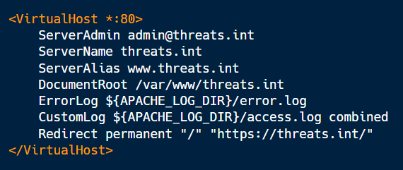

Figure ‎3.11 Apache configration file

Now that our server software is configured, we can download and set up WordPress from their site.

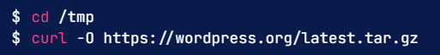

Extract the compressed file to create the WordPress directory structure.

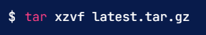

we can add a dummy .htaccess file so that this will be available for WordPress to use later.



We will also copy over the sample configuration file to the filename that WordPress reads.



Now, we can copy the entire contents of the directory into our document root. We are using a dot at the end of our source directory to indicate that everything within the directory should be copied, including hidden files.



Step5: Creating the user interface

Now we will show the user interface that we created for our website "Threats Intelligence".

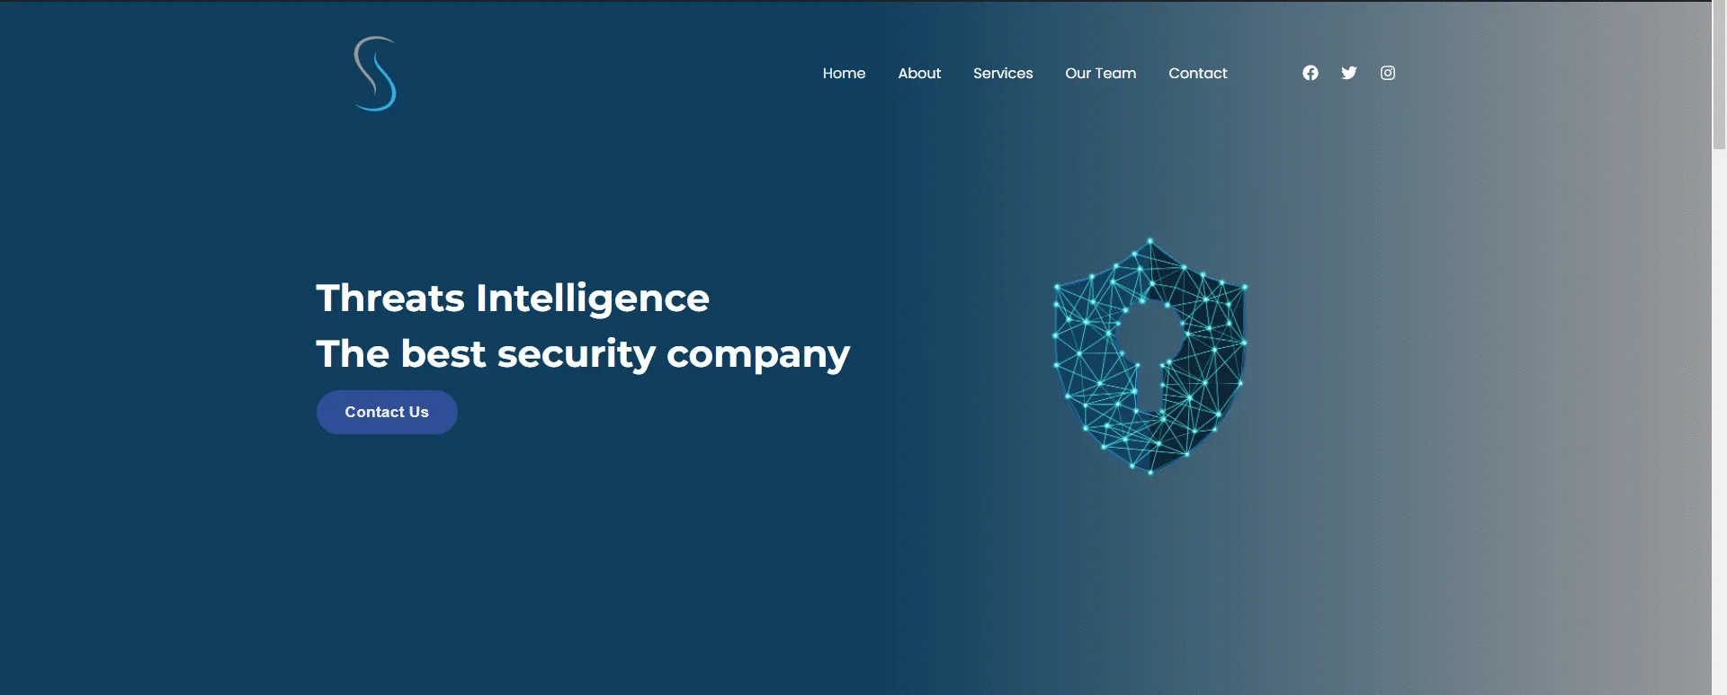

Figure ‎3.12 Threats.int home section



Figure ‎3.13 Threats.int about section

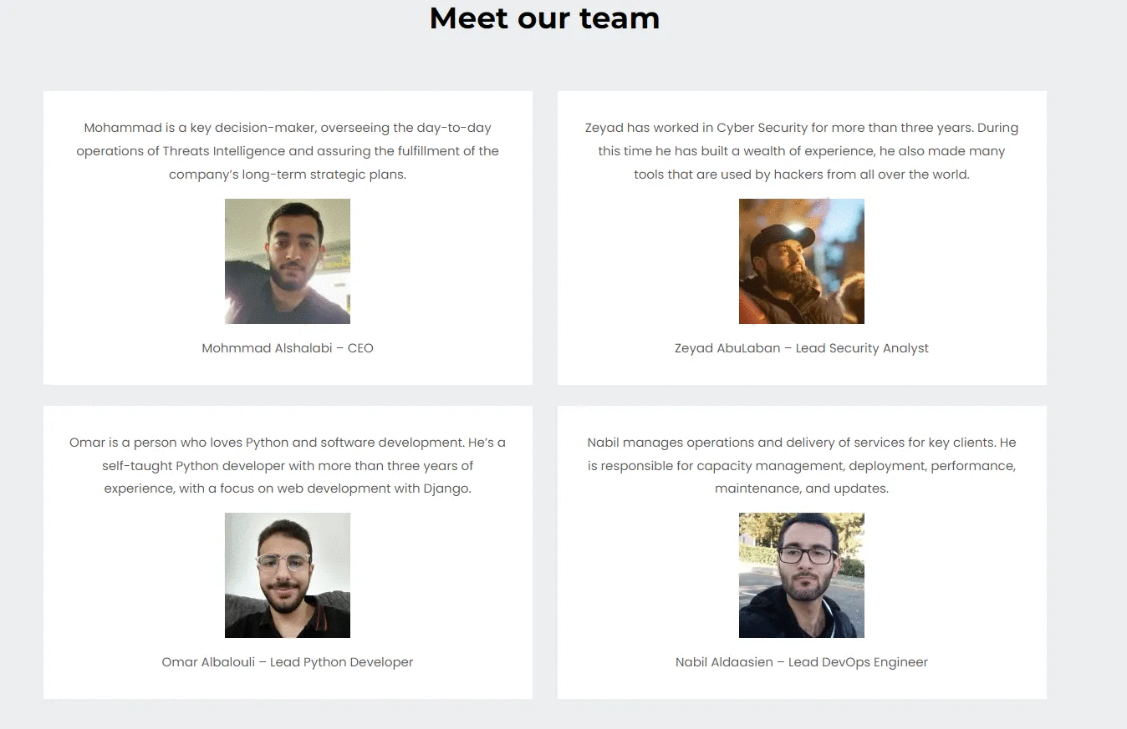

Figure ‎3.14 Threats.int meet our team section

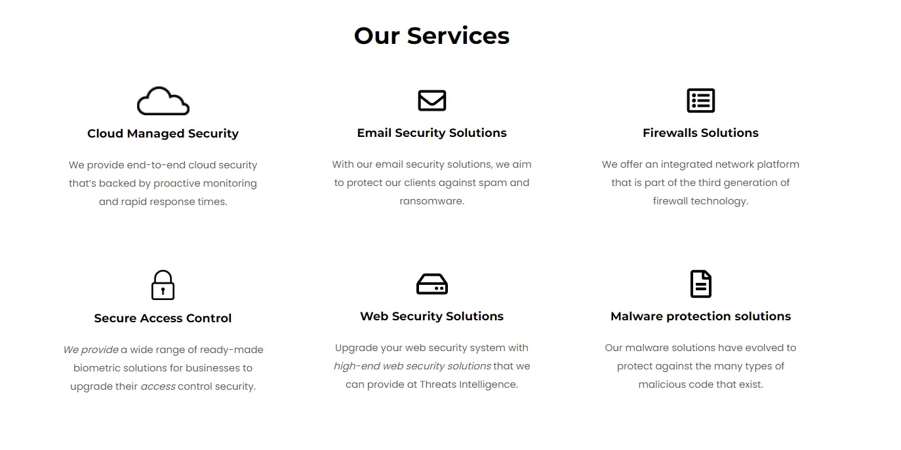

Figure ‎3.15 Threats.int our sevices section

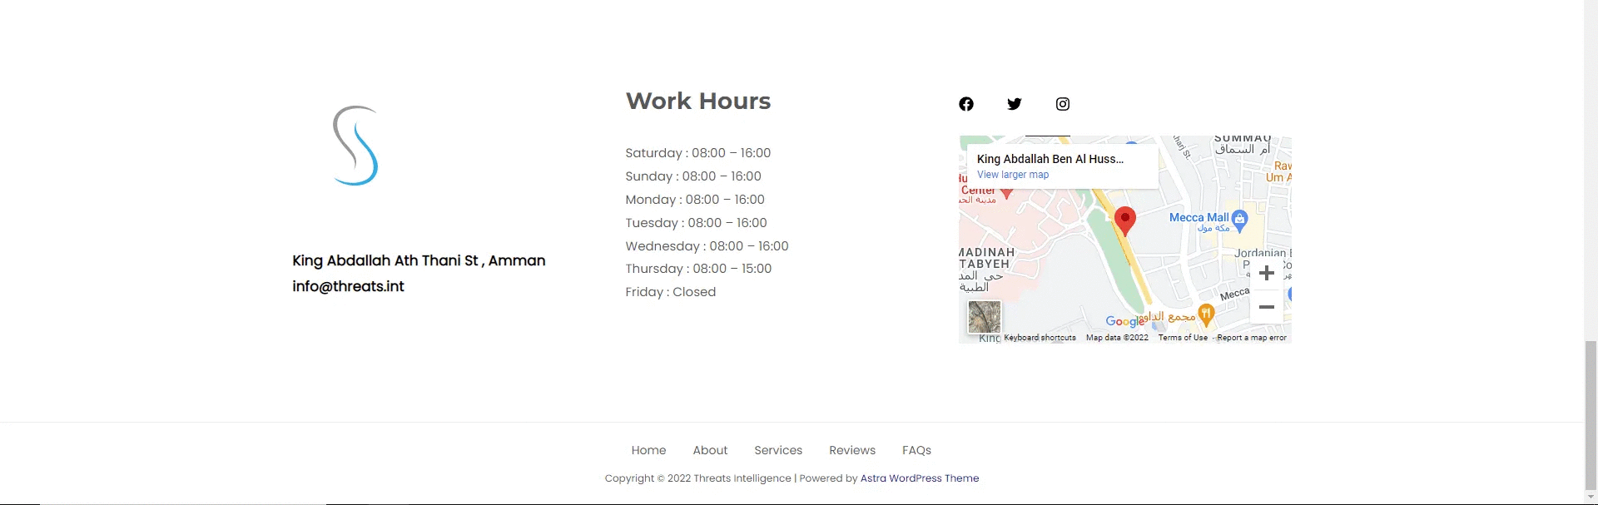

Figure ‎3.16 Threats.int contact section

# CHAPTER 4: IMPLEMENTATION AND RESULTS

We used Vagrant, which is an open-source software product for building and maintaining portable virtual software development environments (Journal, n.d.).

to create our environment in a virtual machine with apps and services automatically installed and configured based on our needs

## Enumeration and information collecting

Enumeration is defined as the process of extracting usernames, machine names, network resources, shares, and services from a system. In this phase, the attacker creates an active connection to the system and performs directed queries to gain more information about the target. The gathered information is used to identify the vulnerabilities or weak points in system security and tries to exploit in the System gaining phase. (Campus, n.d.).

### Nmap scan

Nmap ("Network Mapper") is a [free and open source](https://nmap.org/npsl/) utility for network discovery and security auditing. (NMAP, n.d.).

We’ll use “**nmap**” to get information about the server, including the open ports and the services that are running on it. This is the “**nmap**” command that we’ll be using:

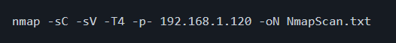

* **-sC:**Performs a script scan using the default set of scripts. (NMAP, n.d.).
* **-sV:**  
  extensive version detection. (NMAP, n.d.).
* **-T4:**Set timing template (higher is faster) so more threads (NMAP, n.d.).
* **-p-:**To scan all ports. (NMAP, n.d.).
* **192.168.1.120:**The IP of the server we want to gather its information.
* **-oN:**Output scan in normal text file. (NMAP, n.d.).
* **NmapScan.txt:**The name of output file

The result of the scan:

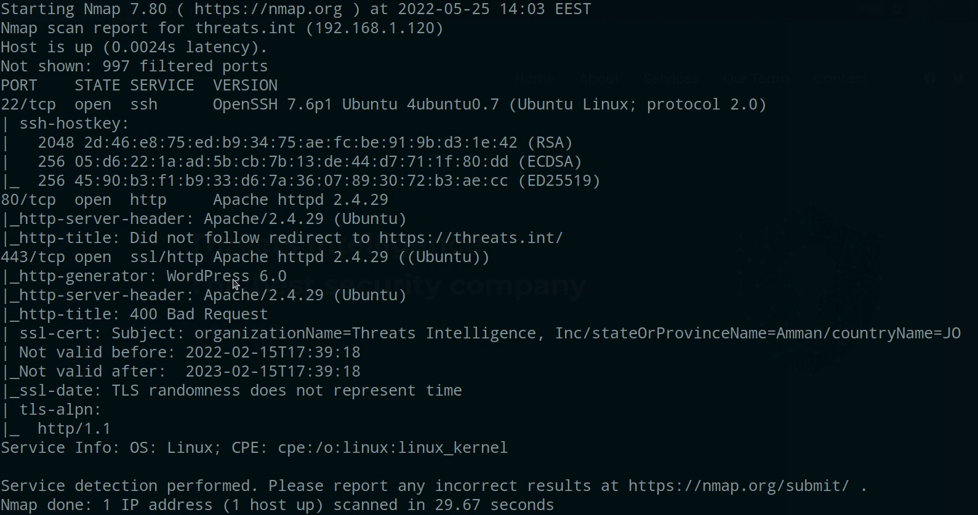

Figure ‎4.1 Nmap scan results

We can see that the server is running Linux Ubuntu OS, an Apache web server with the version 2.4.29, WordPress version 6.0. And we can also see that the organization name is “**Threats Intelligence**” located in Amman, Jordan

We’ll start by enumerating more on WordPress for vulnerable plugins since it’s more interesting than other findings.

### WPSCAN

WPScan WordPress Security Scanner, The WPScan CLI tool is a free, for non-commercial use, black box WordPress security scanner written for security professionals and blog maintainers to test the security of their sites. The WPScan CLI tool uses our database of 28,737 WordPress vulnerabilities. (Scan, n.d.).

We’ll use this command to scan for any vulnerabilities on WordPress website



* **-e ap:0**

This option is for enumerating all plugins (Scan, n.d.).

We can see some interesting findings; we already know that the web server is Apache but there are other information that **wpscan** have found including **XML-RPC**, **Astra** theme and a vulnerable plugin named **wp-with-spritz**, notice that it says that it’s on the latest version but the last update was on 2015 which was a long time ago so it’s old and outdated now.

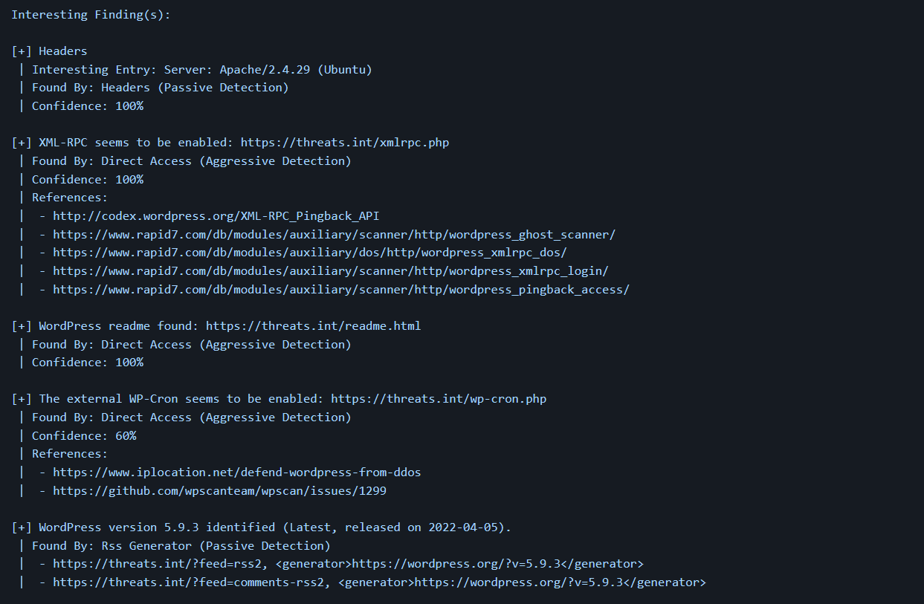

Figure ‎4.2 WPScan tool results (1)

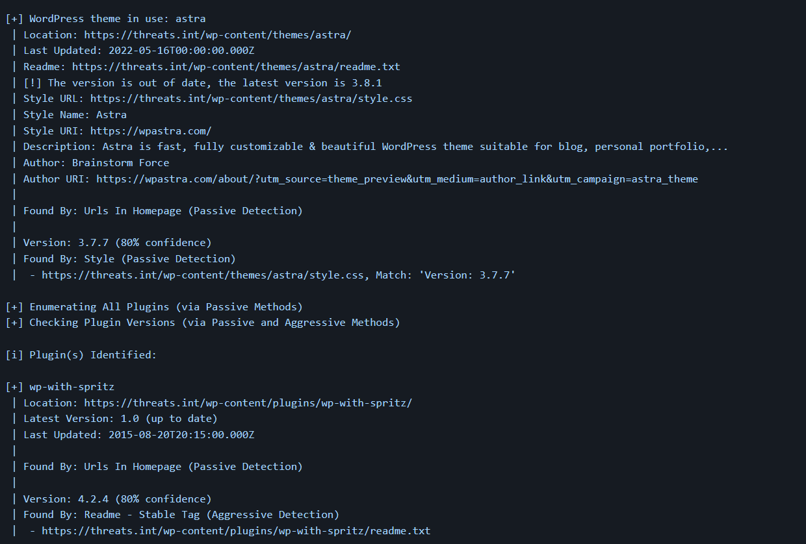

Figure ‎4.3 WPScan tool results (2)

By searching the **wp-with-spritz** plugin on google we find that it exists on **EXPLOIT DATABASE** (DB, n.d.).

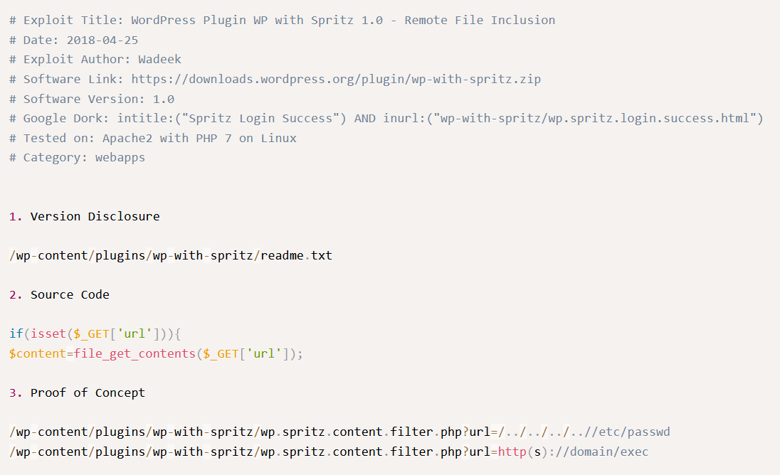

Figure ‎4.4 WP with spritz exploit

There’s a file inclusion vulnerability in the plugin, and they are vulnerabilities often affect web applications that rely on a scripting run time and can allow users to read or execute code on the victim server (Sec, n.d.), we can exploit an LFI (Local File Inclusion) on this server.

## Initial Compromise

The initial compromise occurs when the attacker successfully executes malicious code on one or more systems by exploiting a vulnerability on an Internet-facing system, or by any other means necessary. (Center, n.d.).

The initial compromise here will be due to the LFI vulnerability in the **wp-with-spritz** plugin.

### Exploiting LFI to read admin credentials

Local File Inclusion (LFI) is an attack technique in which attackers trick a web application into either running or exposing files on a web server. LFI attacks can expose sensitive information (Sec, n.d.).

According to the exploit we’ve seen in the previous figure; we can test the existence of the LFI vulnerability in the **wp-with-spritz** plugin by reading the **/etc/passwd** file located in the server by going to this path on the website:



#### Checking if the plugin is vulnerable to LFI

We’ll do this by issuing a **curl** command, **curl** is a tool for transferring data from or to a server. It supports a variety of protocols including HTTP and HTTPS (Se, n.d.)

The **curl** command would be as follows:



* **-k:**  
  This option makes curl skip the certificate verification step and proceed without checking. (Se, n.d.)

The **curl** command will issue an HTTP GET request to the specified path to read the file named **passwd** located under the **/etc** directory on the server

The result output of the command:

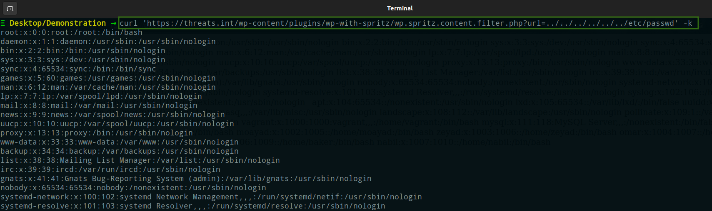

Figure ‎4.5 The results of reading /etc/passwd file using curl command

We can also read the file on a web browser instead of using **curl** by requesting the same file path in the address bar:

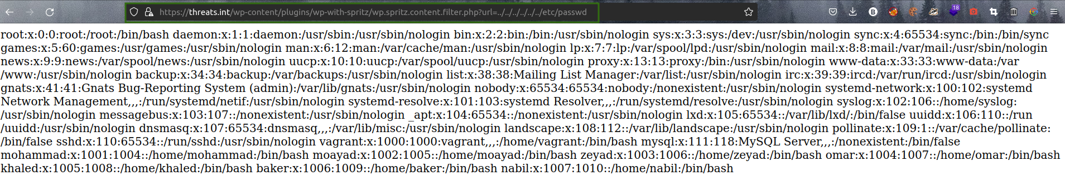

Figure ‎4.6 The results of reading /etc/passwd file using the browser

We can see that we’ve successfully were able to read the **/etc/passwd** file, thus the plugin **wp-with-spritz** is vulnerable and can allow attackers to read arbitrary files on the server that they shouldn’t be allowed or able to read.

#### Reading wp-config.php

One of the most important files in your WordPress installation is the **wp-config.php** file. This file is located in the root of your WordPress file directory and contains your website’s base configuration details, such as database connection information. (WordPress, n.d.)

By exploiting the LFI vulnerability we request the path of the **wp-config.php** file and examine its content:

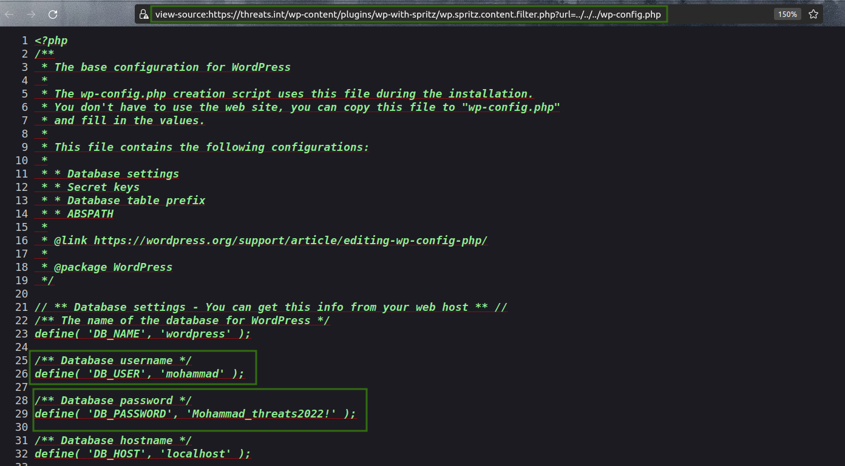

Figure ‎4.7 wp-config.php contents

We can see that there’s a database user named **mohammad** and his password **“Mohammad_threats2022!”**, we were able to read the credentials of the database user **mohammad** and will proceed logging in with those credentials to establish a foothold on the server.

## Establishing Foothold

In this phase the attacker ensures he maintains continued control over a recently compromised system. This occurs immediately following the initial compromise. Typically, the attacker establishes a foothold by installing a persistent backdoor or downloading additional utilities or malware to the victim system. (Center, n.d.)

In our case we will log in as the user **mohammad** and backdoor the server with a malicious custom plugin that we created to let us have a way to access the server.

### Logging in as the user mohammad

We will first log in to the WordPress website as the user **mohammad** with the credentials that we previously found in the **wp-config.php** file

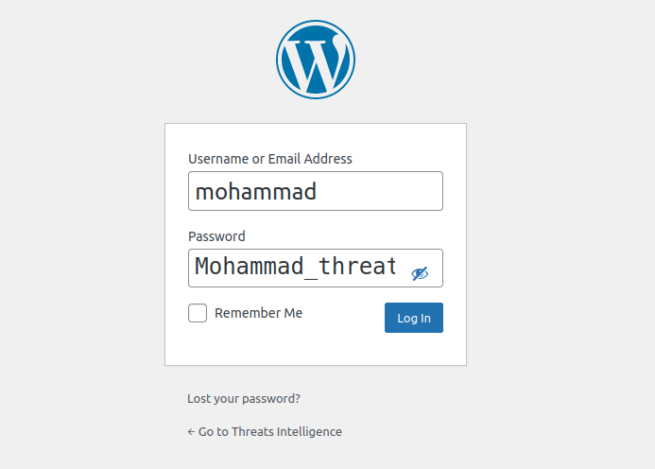

Figure ‎4.8 Threats.int admin panel

We have successfully logged in:

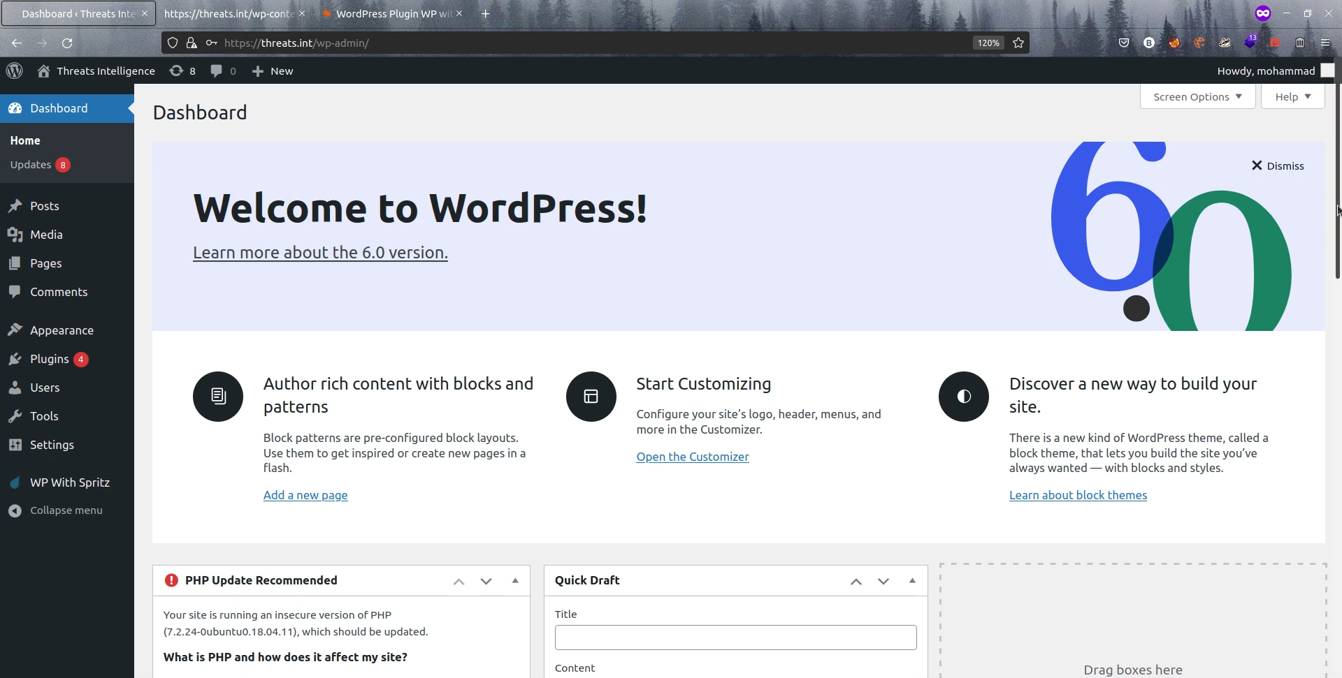

Figure ‎4.9 Threats.int admin dashboard

We will check what privileges **mohammad** has got by navigating to **Users > All Users**

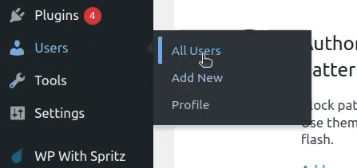

We can see in the below figure that **mohammad** is an **Administrator**, thus he can upload plugins to the website, we can use this privilege to upload our crafted malicious plugin to the website written in **php** and compressed in a **zip** format, since WordPress only accept plugins in **zip** format.

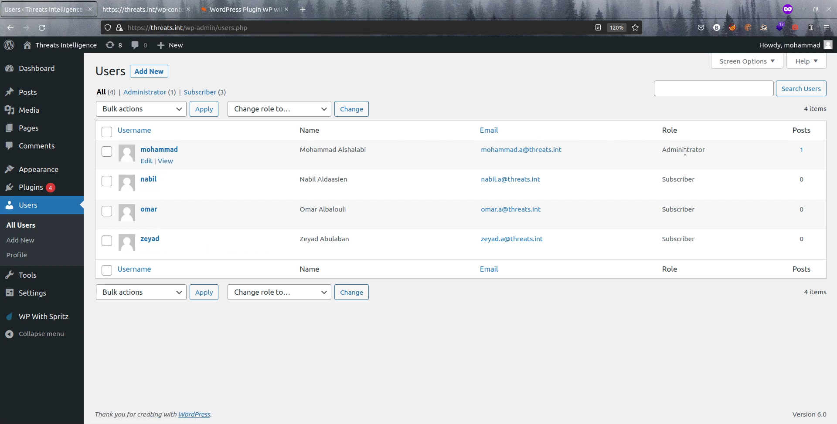

Figure ‎4.10 Threats.int users

### Getting a reverse shell

This **php** code, when executed, will connect from the victim server to the IP address **192.168.1.104**, the attacker IP address, on the port **9001** with an interactive bash shell, hence the name reverse shell. Note that we are not constrained by the port **9001** only, and the attacker IP address might be different from the one in our crafted backdoor.

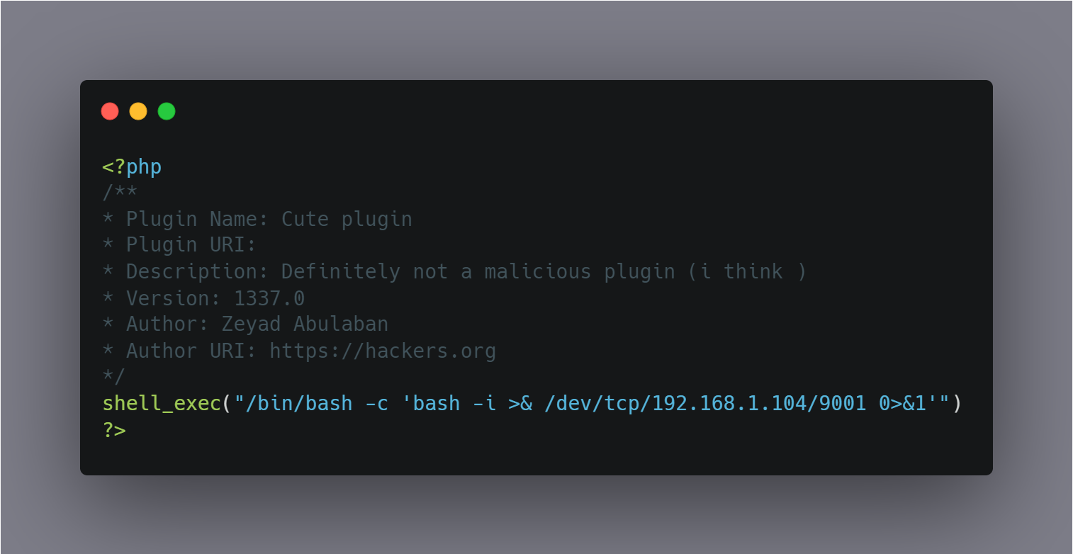

Figure ‎4.11 Wordpress malicious plugin

We must save this code and **zip** it to be able to upload it as a plugin to WordPress.

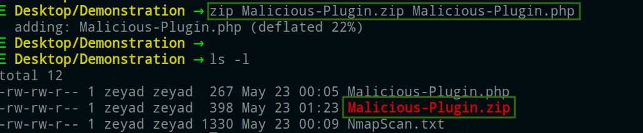

Now on the attacker machine a listener must be running to accept connections from the victim server, or else we can’t communicate with the victim server.

We will use Ncat to listen for a connection from the victim server and interact with it, Ncat is a feature-packed networking utility which reads and writes data across networks from the command line. (7, n.d.)

* **-n:**(Do not resolve hostnames), Completely disable hostname resolution across all Ncat options, such as the destination, source address, source routing hops, and the proxy. All addresses must be specified numerically. (7, n.d.)
* **-l:**To listen for connections on TCP. (7, n.d.)
* **-v:**(Be verbose) Issue Ncat with -v and it will be verbose and display all kinds of useful connection based information. (7, n.d.)
* **-p:**(Specify source port) Set the port number for Ncat to bind to. (7, n.d.)

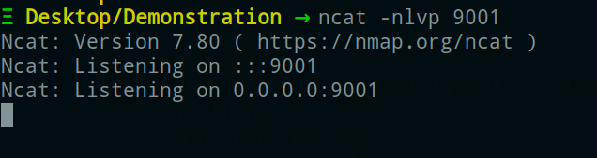

Figure ‎4.12 Netcat listening on port 9001

We can see that Ncat is now listening for connections from port 9001 from any IP address.

Now the attacker machine is ready to receive connections, we want to make a connection happen from the victim server to the attacker machine using our backdoor, we will first upload it to WordPress by navigating to **Plugins > Add New**

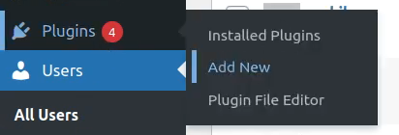

Then by clicking the **Add New** button, and **Upload Plugin**, we can browse for our crafted backdoor and upload and install it to WordPress.

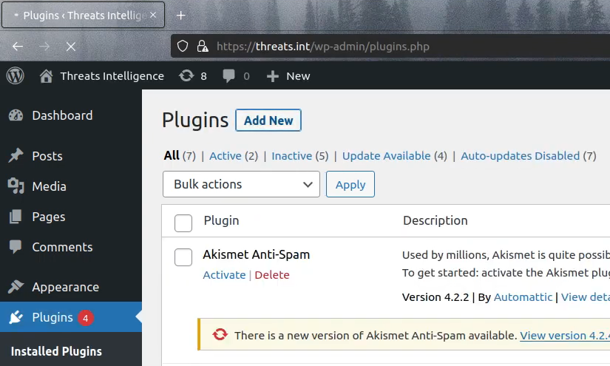

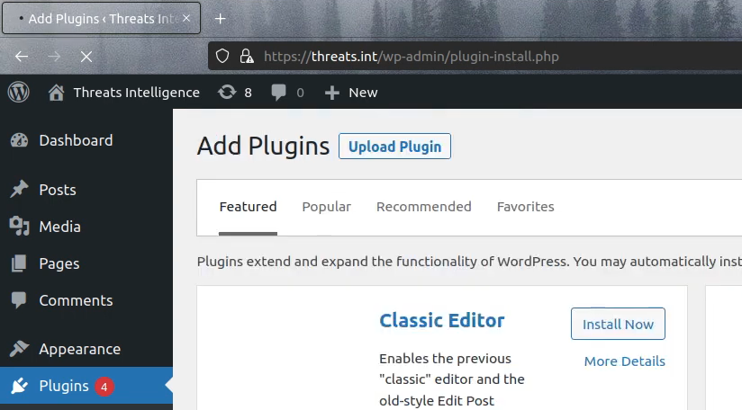

Figure ‎4.13 Upload the malicious plugin

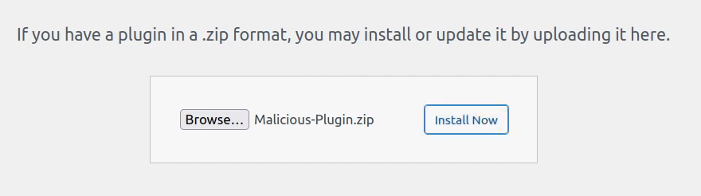

After installing the malicious plugin, we will activate it.

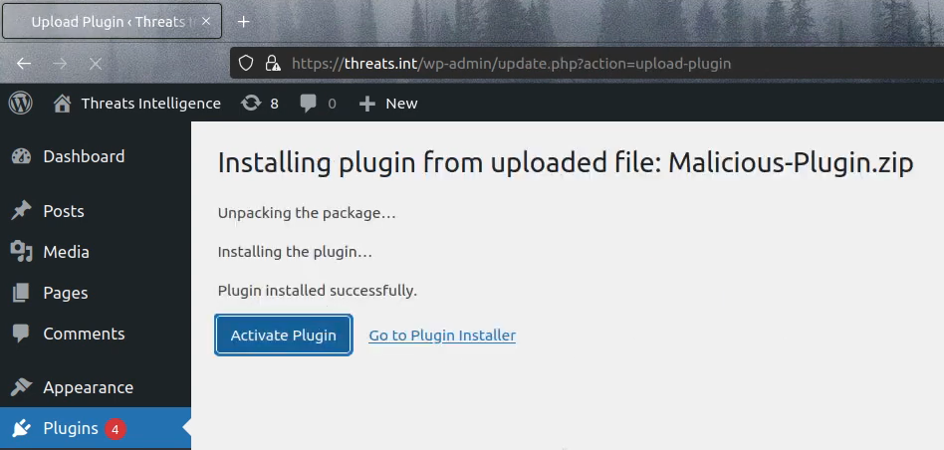

Figure ‎4.14 Activate the malicious plugin

Now right after activating the plugin the attacker will receive a reverse shell, you can notice in the figure below the IP address **192.168.1.120** of the victim server and the output of the **whoami** command [https://man7.org/linux/man-pages/man1/whoami.1.html], the output is the user **www-data**, which is the user that web servers on Ubuntu (Apache, nginx, for example) use by default for normal operation. The web server process can access any file that www-data can access [www-data is the user that web servers on Ubuntu (Apache, nginx, for example) use by default for normal operation. The web server process can access any file that www-data can access.], and since it has limited permissions, the attacker needs to escalate their privileges from the user **www-data** to another user with higher privileges.

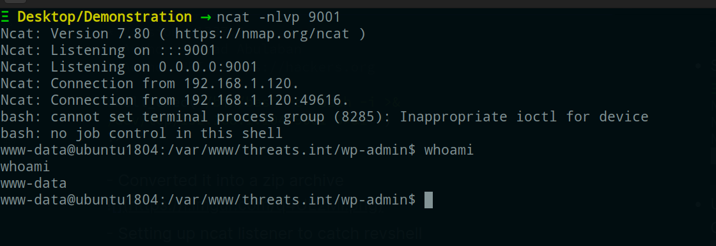

Figure ‎4.15 receive reverse shell

## Escalating Privileges

Now after we’ve gained a foothold on the victim server, we will proceed to the next phase which is escalating our privileges, and what we mean by that is having an access or being able to read, write and execute in the operating system as another user with higher privileges. This phase requires a lot of internal enumeration inside the server to find potential vulnerabilities to exploit them in order to gain root privileges.

### From www-data to baker

After internal enumeration we find an interesting cron job running every minute in the **crontab** file in the path **/etc/crontab** the cron job is being executed by the user **baker** and it’s an execution of a file named **backup** located in the path **/usr/bin/backup**

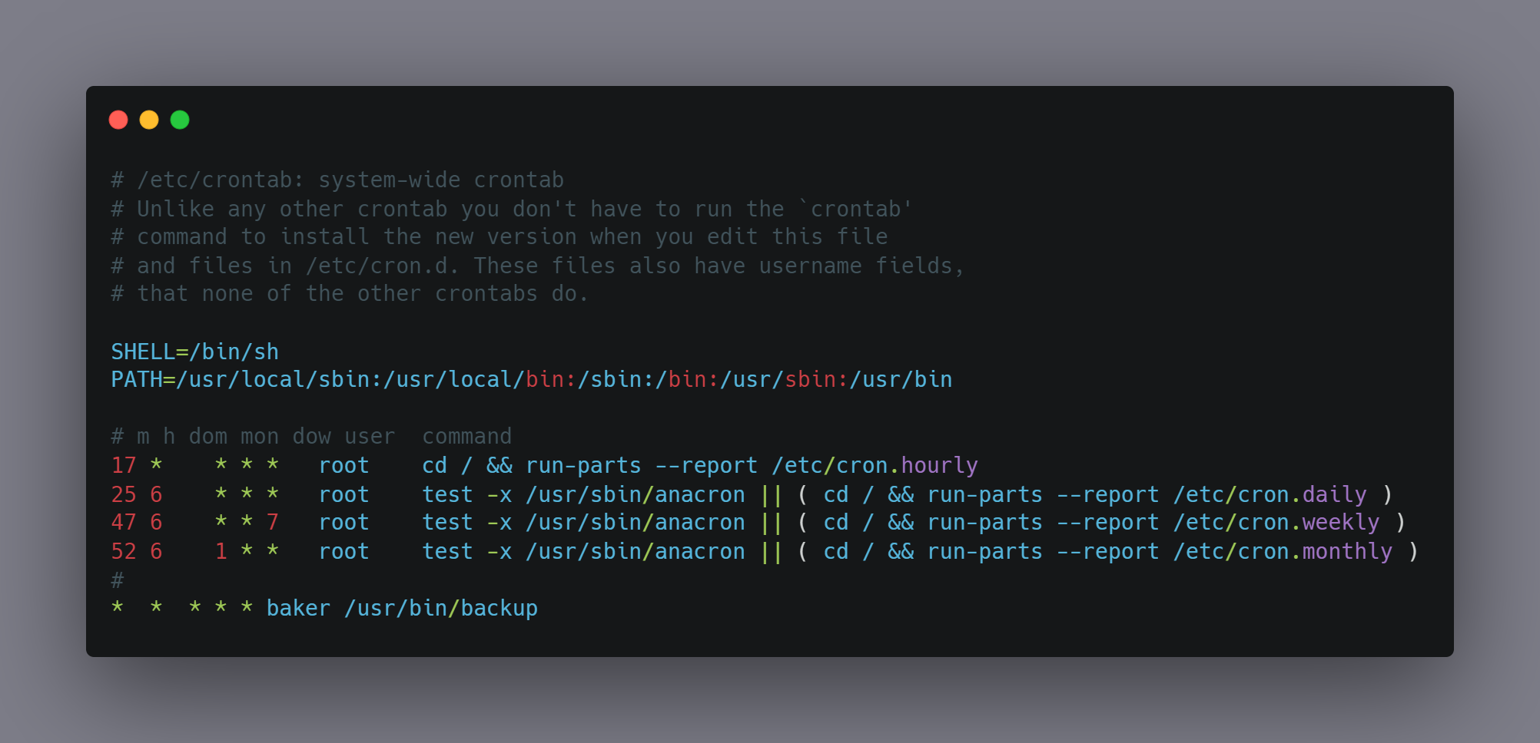

Figure ‎4.16 The cronjob file contents

By examining the contents of **/usr/bin/backup** shown in the below figure we find that it’s a bash script that backs-up the entire content of the **/var/www/threats.int** directory and compress it to a file named **webapp.tgz** under the directory **/home/baker/backups/** it seems like a normal behavior but the interesting part is the asterisk in the **tar** command acting as a wildcard to include all files in the **/var/www/threats.int** directory.

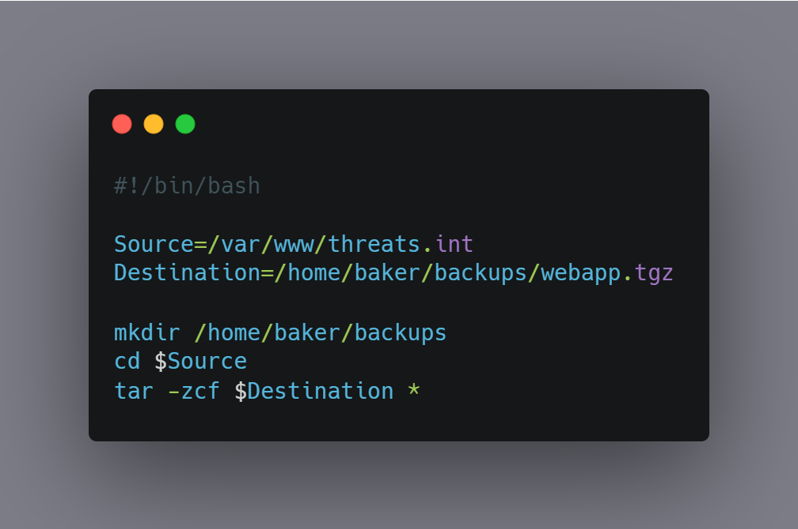

Figure ‎4.17 The backup script

And it’s not a good practice to use and asterisk with **tar** as we can exploit this to make **tar** execute the intended command but with extra options due to the asterisk including all files in the directory and if there was a file named like a **tar** option, **tar** will treat it as an option not as a file, and that’s called a wildcard injection [https://www.hackingarticles.in/exploiting-wildcard-for-privilege-escalation/], what the attacker can do is using some interesting **tar** options:

* **--checkpoint:**Display progress messages every Nth record [ (7, n.d.)].
* **--checkpoint-action:**Run ACTION on each checkpoint [ (7, n.d.)].

The attacker could abuse those two options to make **tar** run a command after the checkpoint is reached, therefore we can execute a command as the user **baker** if we made two files that hold the name of the above options and the command will be running a script that will authorize us to login as the user **baker**, but first we must craft the malicious script in order for **tar** to run it.

The goal of the script is to add our SSH public key to the **authorized_keys** file for the user **baker**, the file is located at **/home/baker/.ssh/authorized_keys**, this will allow the attacker to login as the user **baker** without even knowing his password because we would be authorized to login since our SSH public key exist in the **authorized_keys** here’s the public key of the attacker:

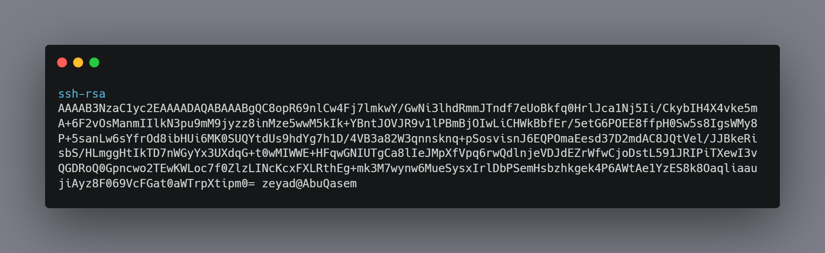

Figure ‎4.18 The RSA key for the attacker machine

We will name the script as **malicious-script.sh**, and the content of the malicious script would be as follows:

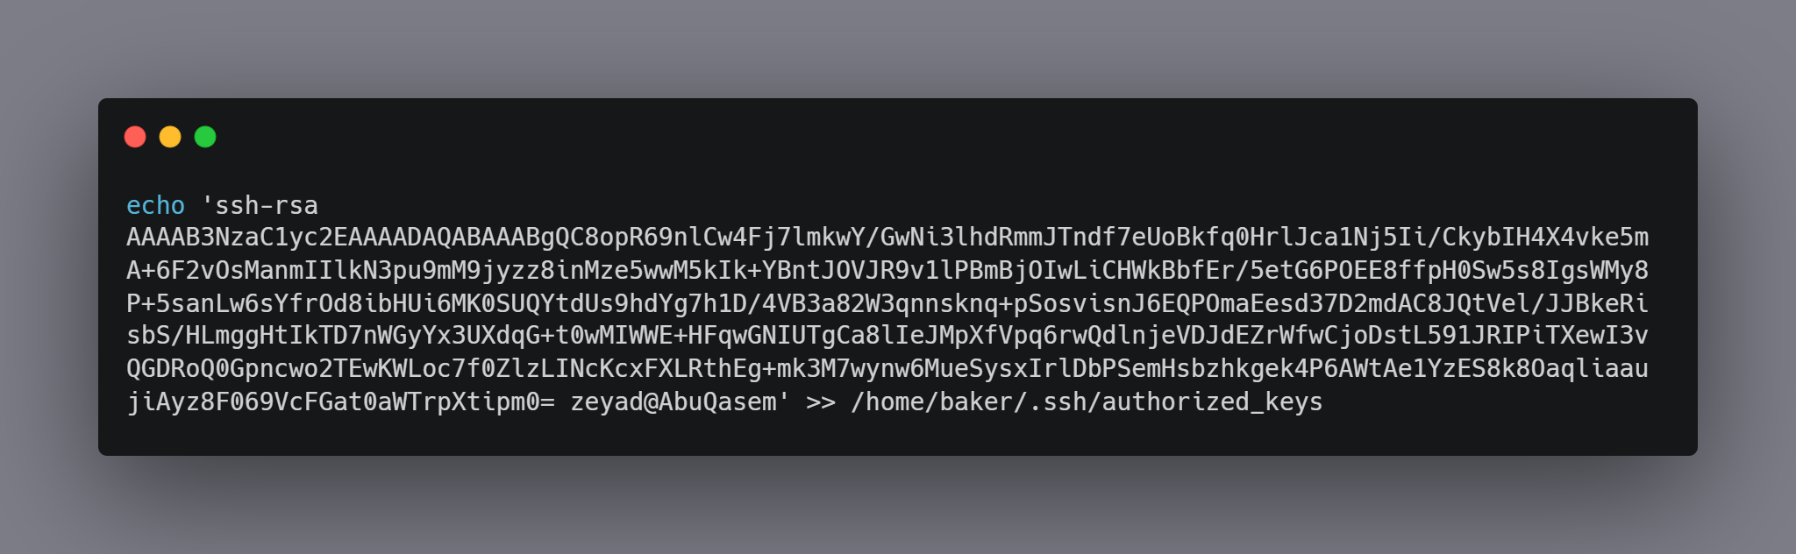

Figure ‎4.19 malicious-script.sh file contents

Now we will create the files in the directory where **tar** is using the asterisk so we could exploit the wildcard injection in **tar**; inside the source directory **/var/www/threats.int** we will issue those two commands to create the files, it doesn’t matter what’s inside the files, in fact we are creating empty files here, what’s important is their names to look exactly like valid **tar** options.

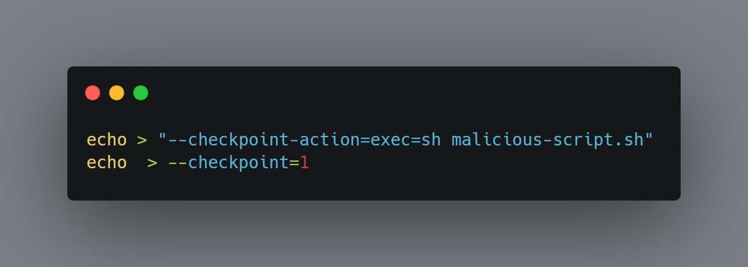

This will allow the attacker to execute the command **sh malicious-script.sh** which by its turn will add our SSH public key to the **authorized_keys** file.

After creating those two files, we will wait for one minute for the cron job start, since it’s running every minute, and then we can simply SSH login to the user **baker** without being asked to provide a password.

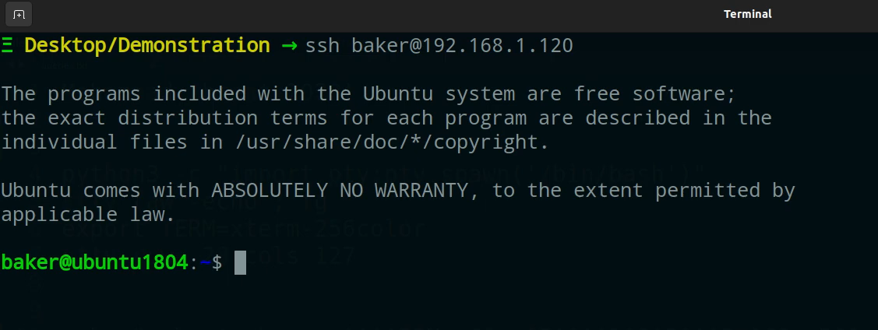

Figure ‎4.20 Trying to connect to baker using ssh

### From baker to nabil

Now since we are logged in as **baker**, we will try to escalate our privileges to another user with higher privileges, that means re-enumerate again for what interesting things **baker** can do.

By issuing the command **sudo -l** we can see that **baker** can execute the file **/usr/bin/restart_services** with root privileges without providing a password, the file is a **bash** script and it’s used by executing the script with **sudo** and providing a service name as an argument to restart that service.

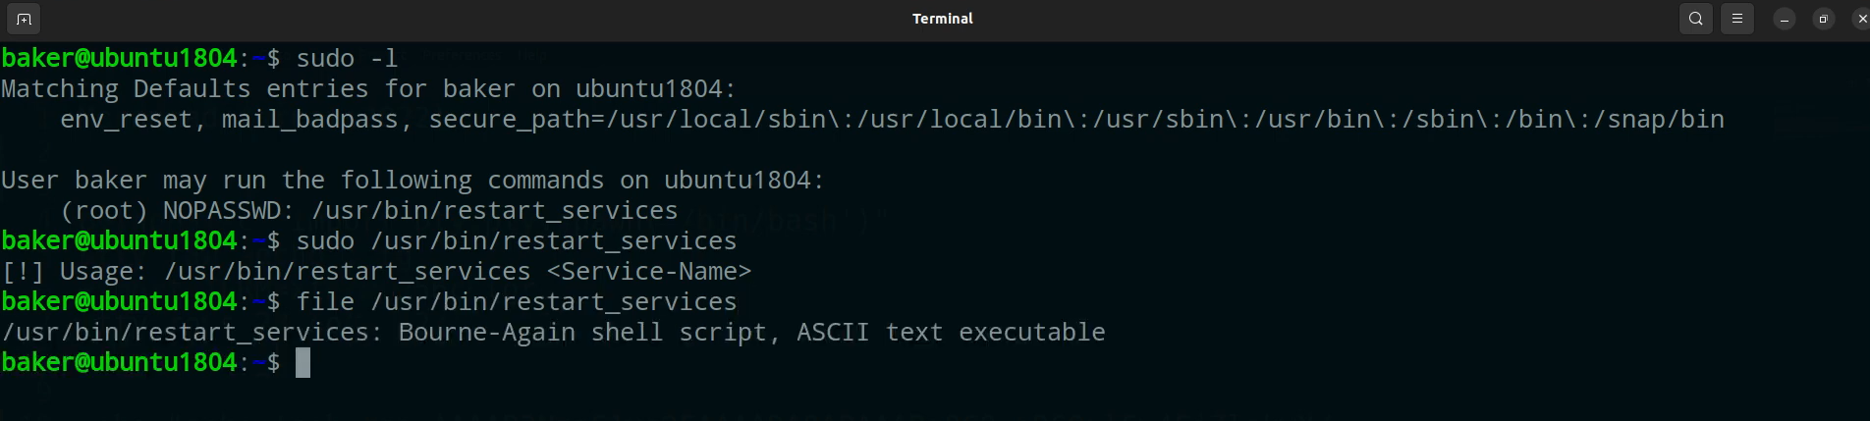

Figure ‎4.21 sudo -l command results

The content of the script:

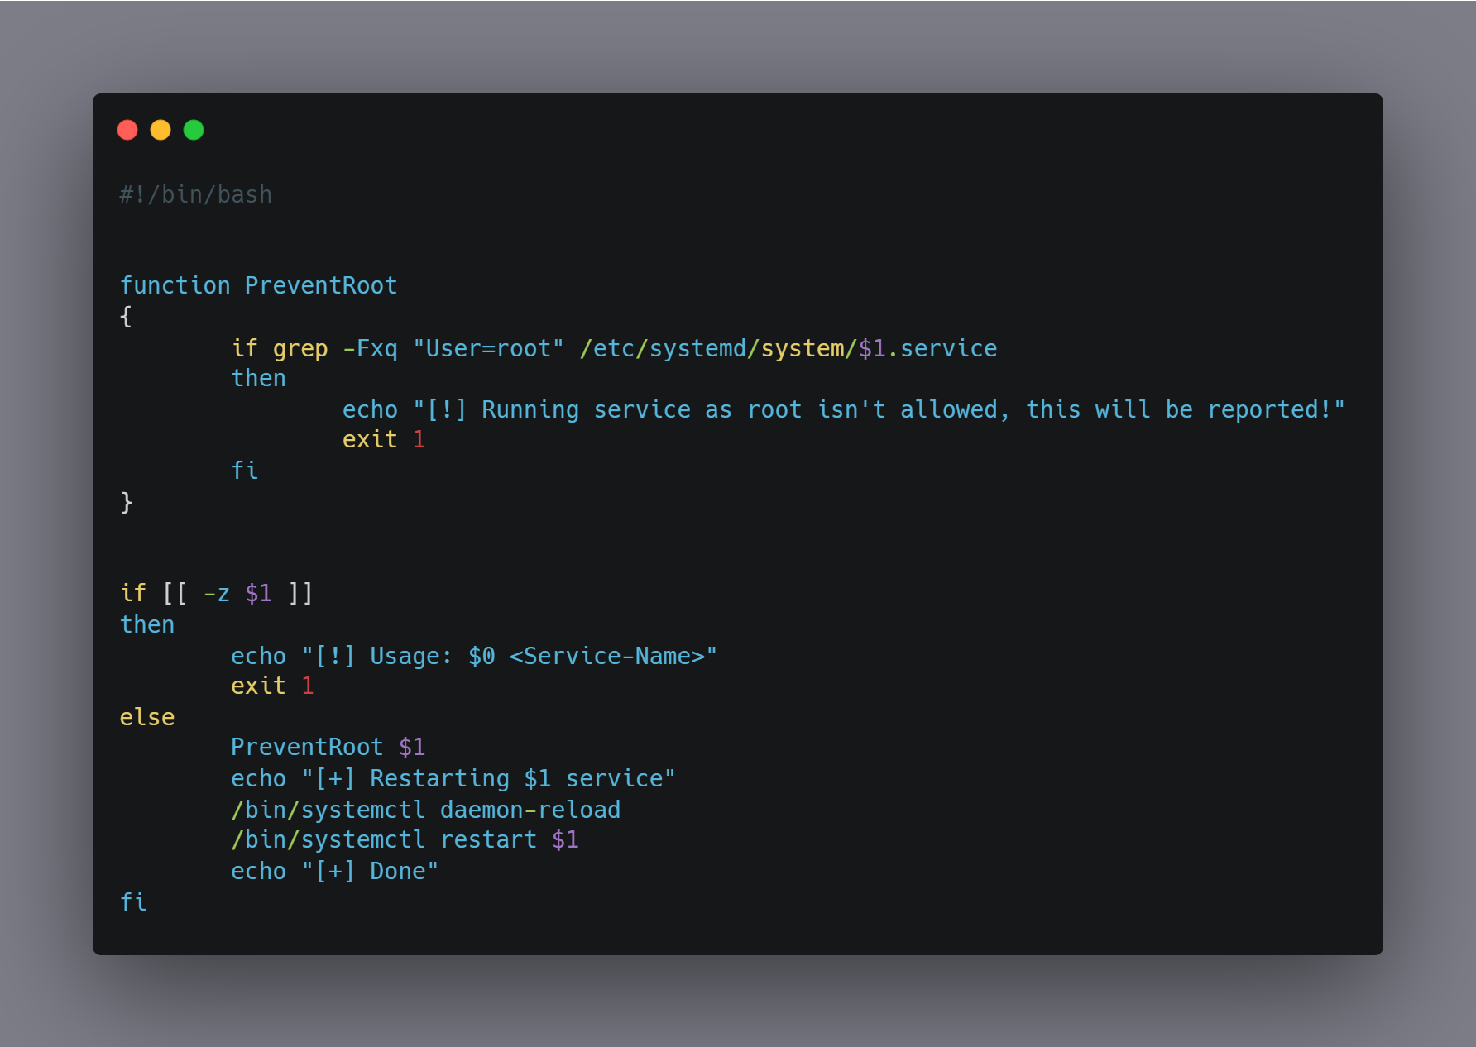

Figure ‎4.22 restart_services script content

It contains a function called **PreventRoot** and it checks if the service file contains the string **“User=root”** and if this condition was true, it will print the message **“[!] Running service as root isn't allowed, this will be reported!”** and exit with the status of 1, but if the condition was false, meaning that the service file did not contain the string **“User=root”**, it will reload the daemon and restart the service then print the message **“[+] Done”**.

That means if there’s a service that isn’t owned by **root** then **baker** can restart it, and by viewing the content of the **/etc/systemd/system/** directory we can see that there’s a service named **debug.service** that is owned by the **developers** group with read and write permissions, meaning anyone in that group can read the file and write to it.

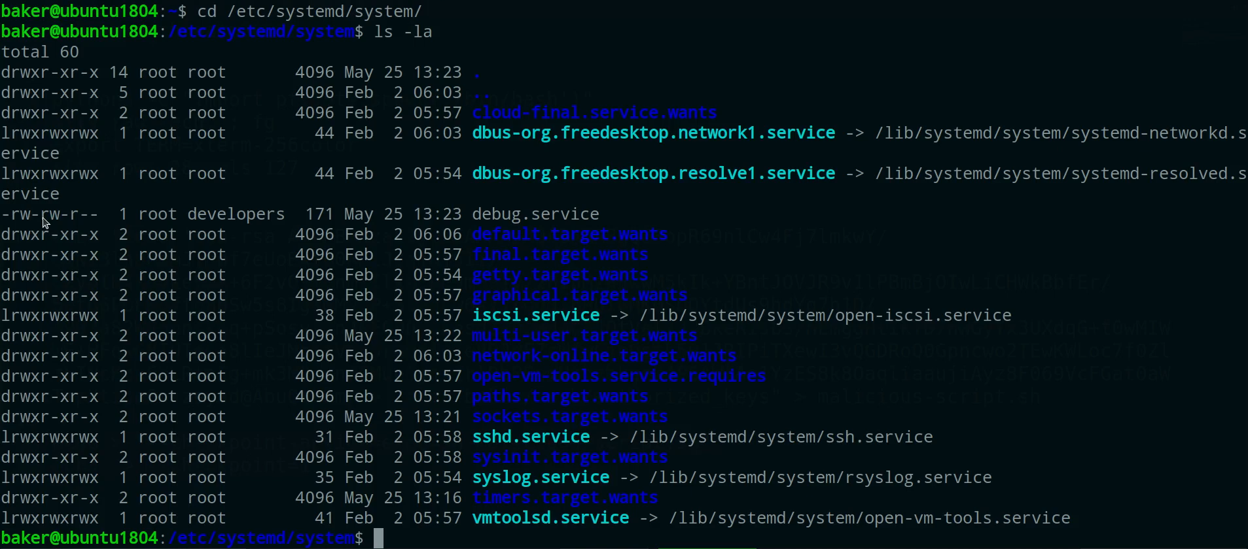

User **baker** is in the **developers** group, this means that he can read and write to the **debug.service** file.

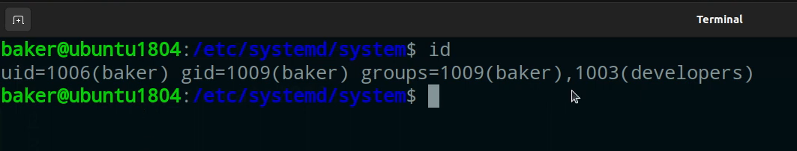

The **debug.service** is for debugging purposes for developers when they create services, by examining the content of the **debug.service** file we can see that we can specify a user to run the service in their permissions and what to execute when the service is started.

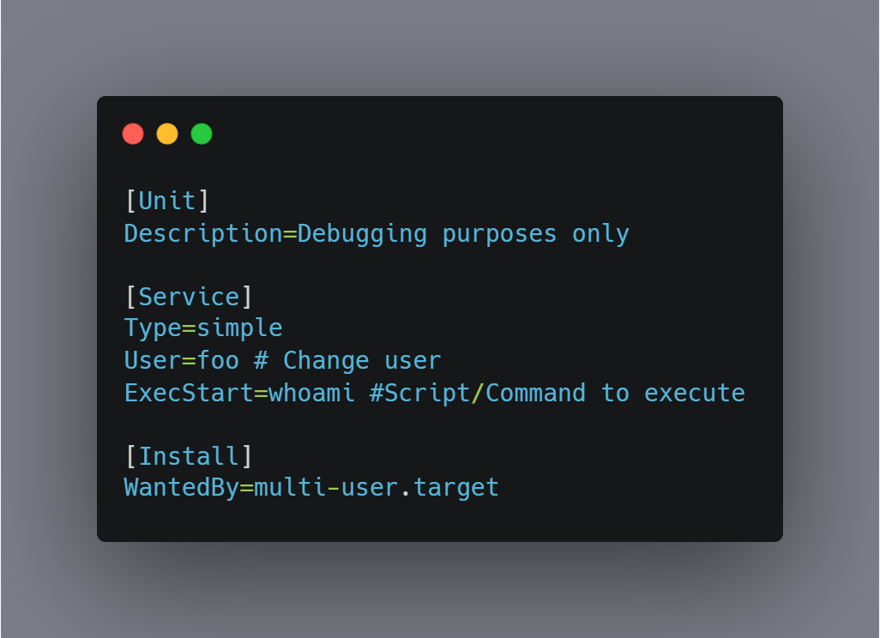

Figure ‎4.23 debug.service file content

We can run the service and specify any user except for **root** because of the **PreventRoot** function, so we will specify another user and get another reverse shell to the port **9999** with their permissions, and we’ll run it as the user **nabil**.

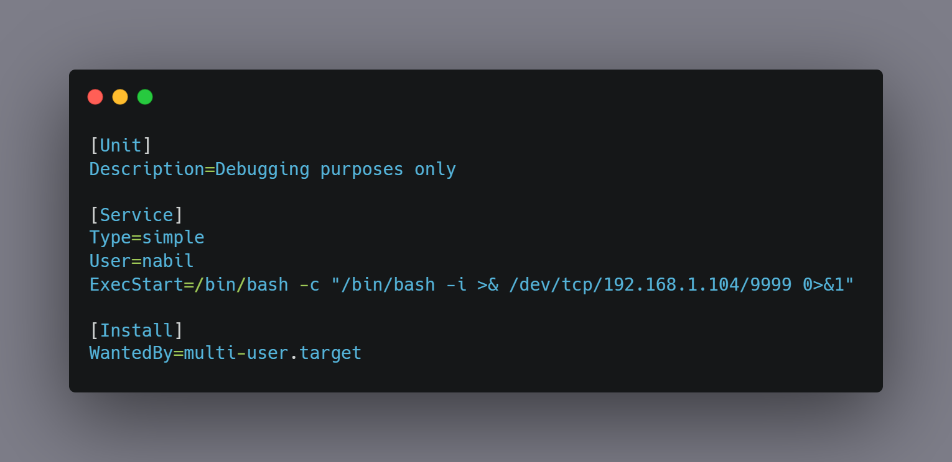

Starting another **Ncat** listener on port **9999** the attacker machine to accept connections from the victim server.

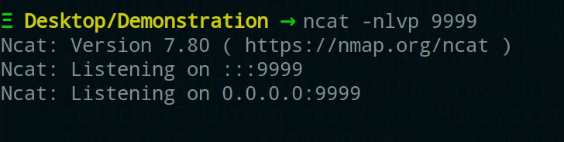

And then restarting the **debug.service** by the user **baker** will get us a reverse shell to the user **nabil**.

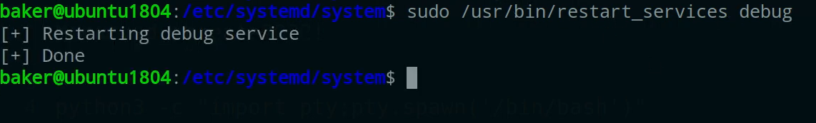

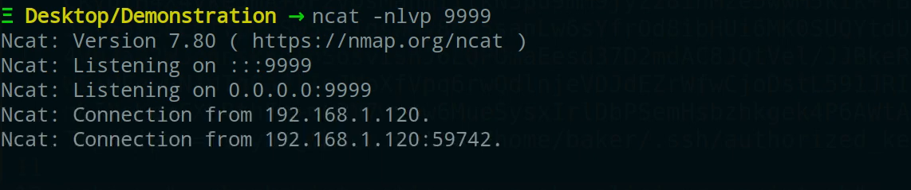

We can now run commands as the user **nabil** such as listing files and **whoami** that will output the username of the current logged in user as shown in the below figure.

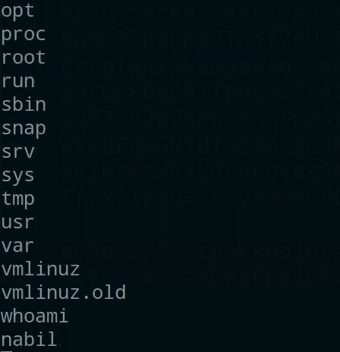

### From nabil to root

User **nabil** got higher privileges than **baker** but we still need to escalate our privileges to the highest privileged user, which is **root**, we now need to enumerate again for interesting privileges that **nabil** has.

By examining the output of **sudo -l** we can notice that **nabil** can also execute the **restart_service** script with **root** permissions but the most interesting privilege is that he can execute **docker** commands with **root** privileges.

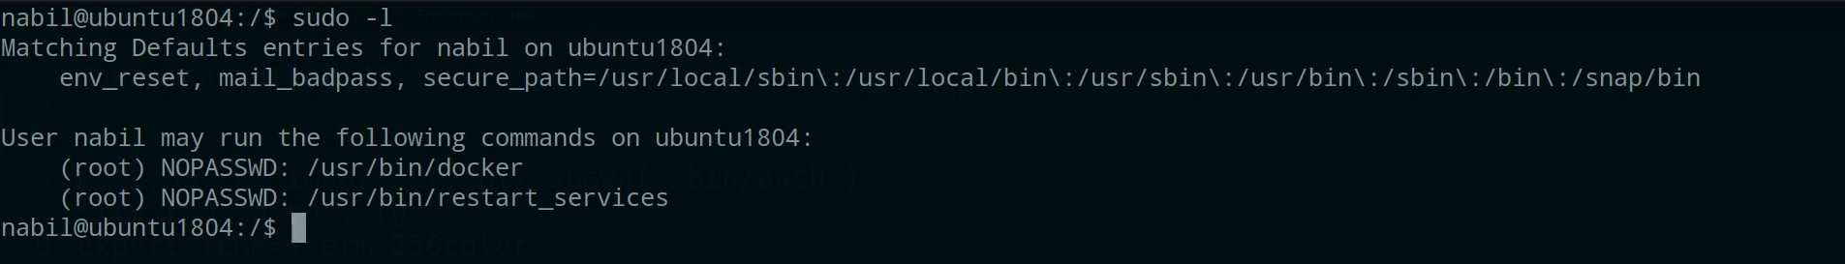

Having the rights to run **docker** with **sudo** is dangerous as we can run a container and mount the whole OS filesystem to the container as a volume, meaning the whole server files and directories can be read from inside the container, thus **nabil** can read any file he’s not allowed to read on the main host OS, such as the files in the **/root** directory, the home directory of the user **root**, therefore **nabil** having the same permissions as the **root** user on the host server.

To do that we can run the container as the following command:

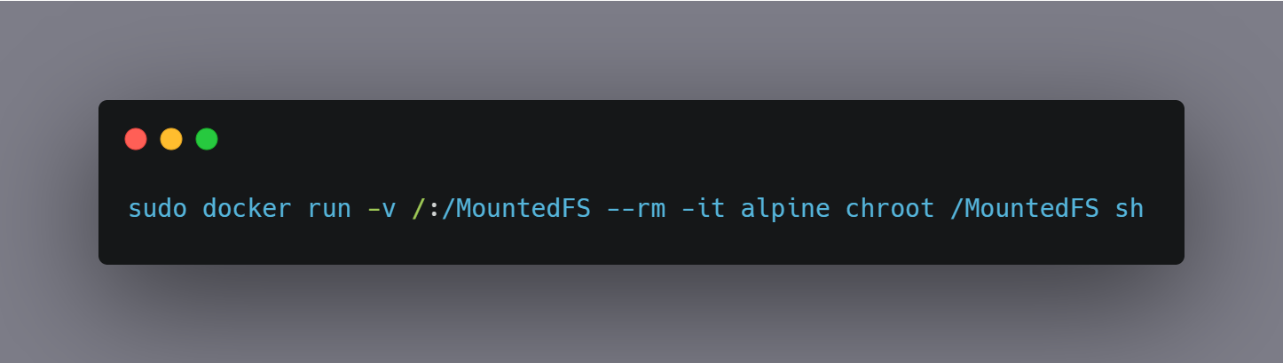

Figure ‎4.24 Run the docker command

* **-v:**  
  Bind mount a volume. [ (Docker, n.d.)]
* **--rm:**Clean up, automatically clean up the container and remove the file system when the container exits. [ (Docker, n.d.)]
* **-it:**For interactive processes (like a shell). [ (Docker, n.d.))]
* **alpine:**A minimal Docker image based on Alpine Linux with a complete package index and only 5 MB in size. [ (Docker, n.d.).]
* **chroot /MountedFS sh:**

changes the root directory to the directory that we named **“MountedFS”** and run a child shell that runs as a separate process from your original shell. [ (IBM, n.d.)]

We can see that we are the **root** user inside the container and since the whole server filesystem is mounted to the container we then have full access to the server.

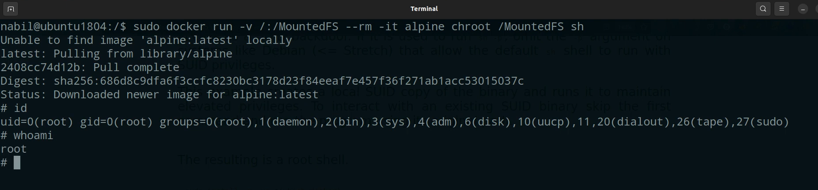

Figure ‎4.25 Getting root access

Changing our directory to the **/root** we find the **proof.txt** file, a file we added in the home directory of the **root** user that can only be read by **root**, being able to read its content **“[+] Congratulations on Successfully Hacking this Server!”** means that we have the highest privilege on the server.

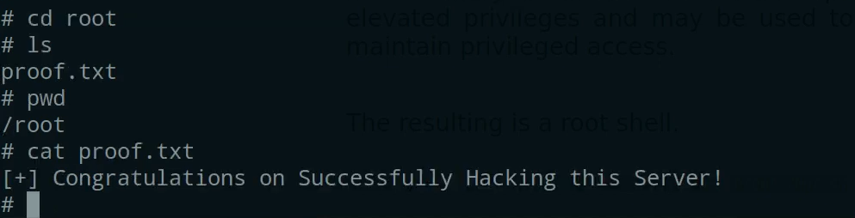

Figure ‎4.26 Congratulations on Successfully Hacking this Server

# CHAPTER 5: CONCLUSIONS AND FUTURE WORK

## Conclusions

Having a regular penetration test, vulnerability assessments on the network components and infrastructure giving cyber awareness sessions, and training employees to follow strict security best rules and practices as well as making sure that the development process pipeline is monitored and have security checks are crucial to enterprises to try to avoid threats as much as possible although it will ensure the availability, integrity, and confidentiality of the Personally Identifiable Information data.

## Future Work

- Create a full network infrastructure with various operating systems.

- Configure servers with more sophisticated exploitation scenarios.

- Create a writeup for every exploitation scene.

- Make sure to update and add more vulnerabilities over time.

# References

7, M., n.d. *ncat(1) — Linux manual page/ CONNECT MODE OPTIONS.* [Online]   
Available at: https://man7.org/linux/man-pages/man1/ncat.1.html#:~:text=(Specify%20source%20port)

7, M., n.d. *ncat(1) — Linux manual page/ DESCRIPTION.* [Online]   
Available at: https://man7.org/linux/man-pages/man1/ncat.1.html#:~:text=Ncat%20is%20a%20feature%2Dpacked%20networking%20utility%20which%20reads%20and%0A%20%20%20%20%20%20%20writes%20data%20across%20networks%20from%20the%20command%20line

7, M., n.d. *ncat(1) — Linux manual page/ EXAMPLES.* [Online]   
Available at: https://man7.org/linux/man-pages/man1/ncat.1.html#:~:text=Listen%20for%20connections%20on%20TCP

7, M., n.d. *ncat(1) — Linux manual page/ MISC OPTIONS.* [Online]   
Available at: https://man7.org/linux/man-pages/man1/ncat.1.html#:~:text=(Do%20not%20resolve%20hostnames)

7, M., n.d. *ncat(1) — Linux manual page/ OUTPUT OPTIONS.* [Online]   
Available at: https://man7.org/linux/man-pages/man1/ncat.1.html#:~:text=%2C%20%2D%2Dverbose-,(Be%20verbose),-Issue%20Ncat%20with

7, M., n.d. *tar(1) — Linux manual page/ Informative output.* [Online]   
Available at: https://man7.org/linux/man-pages/man1/tar.1.html#:~:text=Display%20progress%20messages%20every%20Nth%20record

7, M., n.d. *whoami(1) — Linux manual page.* [Online]   
Available at: https://man7.org/linux/man-pages/man1/whoami.1.html

Campus, G., n.d. *Enumeration and its Types.* [Online]   
Available at: https://www.greycampus.com/opencampus/ethical-hacking/enumeration-and-its-types#:~:text=Enumeration%20is%20defined,System%20gaining%20phase

Center, C., n.d. *CYBER ATTACK LIFECYCLE/ Establish Foothold.* [Online]   
Available at: https://www.iacpcybercenter.org/resource-center/what-is-cyber-crime/cyber-attack-lifecycle/#:~:text=other%20means%20necessary.-,Establish%20Foothold,-%3A%20The%20attacker%20ensures

Center, C., n.d. *CYBER ATTACK LIFECYCLE/ Initial Compromise.* [Online]   
Available at: https://www.iacpcybercenter.org/resource-center/what-is-cyber-crime/cyber-attack-lifecycle/#:~:text=socially%2Dengineer%20employees-,Initial%20Compromise,-%3A%20The%20attacker%20successfully

DB, E., n.d. *WordPress Plugin WP with Spritz 1.0 - Remote File Inclusion.* [Online]   
Available at: https://www.exploit-db.com/exploits/44544

Docker, n.d. *docker docs/ alpine.* [Online]   
Available at: https://hub.docker.com/_/alpine#:~:text=Alpine%20Linux%20is%20a%20Linux,utilities%20and%20even%20production%20applications

Docker, n.d. *docker docs/ Clean up (--rm).* [Online]   
Available at: https://docs.docker.com/engine/reference/run/#clean-up---rm

Docker, n.d. *docker docs/ Foreground.* [Online]   
Available at: https://docs.docker.com/engine/reference/run/#:~:text=For%20interactive%20processes%20(like%20a%20shell)

Docker, n.d. *docker docs/ VOLUME (shared filesystems).* [Online]   
Available at: https://docs.docker.com/engine/reference/run/#volume-shared-filesystems

IBM, n.d. *chroot — Change the root directory for the execution of a command.* [Online]   
Available at: https://www.ibm.com/docs/en/zos/2.1.0?topic=descriptions-chroot-change-root-directory-execution-command

Journal, L., n.d. *Introducing Vagrant.* [Online]   
Available at: http://www.linuxjournal.com/content/introducing-vagrant

Journal, L., n.d. *linuxjournal.* [Online]   
Available at: http://www.linuxjournal.com/content/introducing-vagrant

NMAP, n.d. *Get Nmap 7.92.* [Online]   
Available at: https://nmap.org/#:~:text=Nmap%20(%22Network%20Mapper%22)%20is%20a%20free%20and%20open%20source%20utility%20for%20network%20discovery%20and%20security%20auditing

NMAP, n.d. *Nmap Command-line Arguments.* [Online]   
Available at: https://nmap.org/book/nse-usage.html#:~:text=Performs%20a%20script%20scan%20using%20the%20default%20set%20of%20scripts

NMAP, n.d. *Options Summary.* [Online]   
Available at: https://nmap.org/book/man-briefoptions.html#:~:text=Set%20timing%20template%20(higher%20is%20faster)

Ocean, D., n.d. *How To Install Linux, Apache, MySQL, PHP (LAMP) stack on Ubuntu 18.04.* [Online]   
Available at: https://www.digitalocean.com/community/tutorials/how-to-install-linux-apache-mysql-php-lamp-stack-ubuntu-18-04

Ocean, D., n.d. *How To Install WordPress with LAMP on Ubuntu 18.04.* [Online]   
Available at: https://www.digitalocean.com/community/tutorials/how-to-install-wordpress-with-lamp-on-ubuntu-18-04

Ocean, D., n.d. *How To Set Up Apache Virtual Hosts on Ubuntu 18.04 [Quickstart].* [Online]   
Available at: https://www.digitalocean.com/community/tutorials/how-to-set-up-apache-virtual-hosts-on-ubuntu-18-04-quickstart

Scan, W., n.d. *Enumeration Options.* [Online]   
Available at: https://blog.wpscan.com/wpscan-user-documentation/#:~:text=detection%C2%A0option.-,Enumeration,-Options

Scan, W., n.d. *WPScan WordPress Security Scanner.* [Online]   
Available at: https://wpscan.com/wordpress-security-scanner#:~:text=WPScan%20WordPress%20Security,28%2C737%20WordPress%20vulnerabilities.

Sec, B., n.d. *What are File Inclusion Vulnerabilities?.* [Online]   
Available at: https://brightsec.com/blog/file-inclusion-vulnerabilities/#:~:text=File%20Inclusion%20vulnerabilities%3F-,What%20are%20File%20Inclusion%20Vulnerabilities%3F,-File%20Inclusion%20vulnerabilities

Sec, B., n.d. *What is Local File Inclusion (LFI)?.* [Online]   
Available at: https://brightsec.com/blog/local-file-inclusion-lfi/#:~:text=What%20is%20Local%20File%20Inclusion%20(LFI)%3F

Se, C., n.d. *curl.1 the man page.* [Online]   
Available at: https://curl.se/docs/manpage.html#:~:text=curl%20is%20a%20tool%20for%20transferring%20data%20from%20or%20to%20a%20server

WordPress, n.d. *Editing wp-config.php.* [Online]   
Available at: https://wordpress.org/support/article/editing-wp-config-php/#:~:text=One%20of%20the%20most%20important%20files%20in%20your%20WordPress%20installation%20is%20the%20wp%2Dconfig.php%20file.%20This%20file%20is%20located%20in%20the%20root%20of%20your%20WordPre